

Final Project Stream Three

motorholics django project

Christine Wilde | Full Stack Software Development | 13.10.2018

Contents

[**Project Brief** 3](#_Toc527196901)

[Frameworks 4](#_Toc527196902)

[Back-end 4](#_Toc527196903)

[Front-end 4](#_Toc527196904)

[Other 4](#_Toc527196905)

[Project deployment 5](#_Toc527196906)

[**Django Project Start Up** 11](#_Toc527196907)

[**The django Accounts app** 14](#_Toc527196908)

[**flatpages** 26](#_Toc527196909)

[**The django blog app** 30](#_Toc527196910)

[**The django Thread (forum) app** 39](#_Toc527196911)

[**motorholics project testing** 47](#_Toc527196912)

[**motorholics – the complete product** 67](#_Toc527196913)

[**reusable apps** 78](#_Toc527196914)

[Reusable app 1 – blog 78](#_Toc527196915)

[Reusable app 2 – threads 81](#_Toc527196916)

[Reusable app 3 – accounts 84](#_Toc527196917)

[Reusable app 3 – polls 86](#_Toc527196918)

[**Project Deployment Steps** 88](#_Toc527196919)

[**Appendix A: References** 112](#_Toc527196920)

## Project Brief

The goal of the stream three project is to build a Django project composed of multiple applications (apps). The Django project should include an ecommerce element to it, establish a login/logout authentication mechanism for users to the Website and connect to a database to store Website data.

After considering a few ideas the Motorholics Website was born, aiming to connect all users and car enthusiasts to car mechanics for advice and assistance with any car issues or subject interest.

This meant that the Website should contain a discussion feature for all users to comment on. It also allows scope for the mechanics to write any articles of interest to further educate users. Therefore, a forum and a blog were decided on.

The mechanics can respond to users’ issues via the forum and in a real world example can be ‘searched’ via search engine such as Google. However, since the mechanics would be spending the time and offering valuable car advice where normally users would refer to a car garage it was decided that a subscription facility should be established so that those users requiring repeated assistance can obtain first hand quick advice on a prolonged basis.

Therefore, the main features of this Django Website are:

* Car Blog (mechanics car topics)
* Car Forum (mechanics and users discussion forum – help site!)
* User Registration (register to ask for advice via a small subscription)

#### Technical inclusions

The list below presents the technologies used to accomplish the Django Motorholics Website from the initial prototype versions to the completed Website product.

### Frameworks

Django 1.11.15

* The Django framework allowed creation of:

**Models** – this allowed classes, functions and tables to be established that could then be updated to the database.

**Views** – this established the business logic (e.g. the user registration and how to handle email and password validation). The views link to the models and html templates

**Templates** – here is where all the html templates are kept which presents the visual representation of the codes and it’s functions.

### Back-end

SQLite

* The open source SQL database allowed all the models and their data to be stored. This is included with the Python so conveniently no further installations are required.

### Front-end

(Semantic) HTML5

* Website HTML structure – DOM

CSS

* General and advanced Website display including animation (external style sheet)

JavaScript

* JavaScript language was used to include a responsive ‘best car’ feature

Bootstrap

* The free front-end framework in order to contribute to designing an eye-catching Website

### Other

Disqus

* Disqus was used to include a global comments platform for the Motorholic blog

Stripe

* Stripe API’s allow payment processing and this was used for the user registration/subscription model

Tinymce

* Tinymce is a WYSIWYG HTML editor and allows users to update threads in a pretty table on the Motorholics forum

Font Awesome

* Font Awesome was used for add icons to make the functions more enjoyable such as the car icon on the buttons

### Project deployment

GitHub, GitBash, GitHub Pages

* + Hosting the software project files and version control
  + Creating repositories and branches for project files

Heroku

* + Heroku was used to host the project’s files and application

#### The Prototype

As with the other projects the prototype was first roughly sketched on paper – this approach is very useful to get ideas down quickly and can be easily discarded and started again!

Mockplus prototyping free limited edition was chosen for its ease of use and convenient tool belt. The focus was on a smart useful Website with intelligent coding.

The below pictures show the first sketches for the Website. It was initially thought that a MOT/Service booking would be helpful although since there are many available the idea turned into a more blog/forum help site later on.

Figure 1. Early sketch of Motorholic components

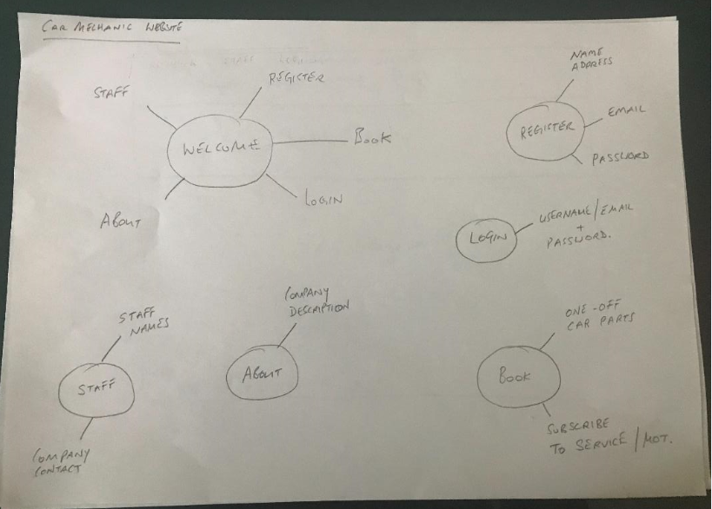

Figure 2. Simple Welcome page sketch

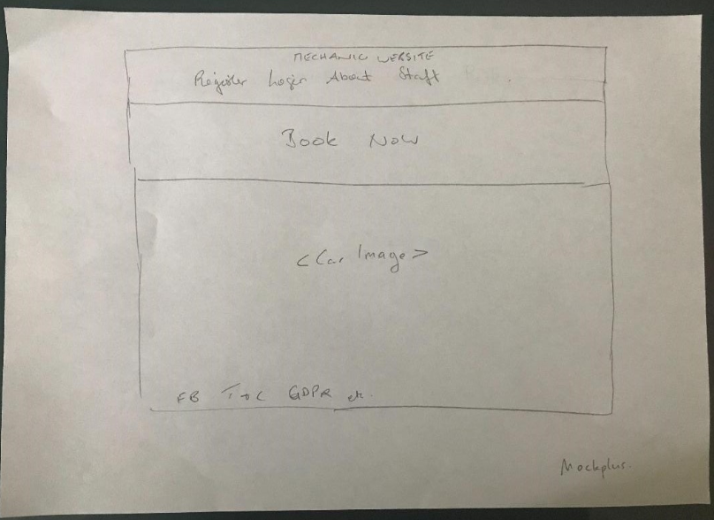

After the paper sketches were done and some ideas put down the drawings were transferred to Mockplus as a prototype project.

The Welcome page was eventually built close to the prototype as was the blog. However the design was updated based on payment being taken when users register. This was originally to be separated i.e. Register on one page and if you decided on a subscription this could be done under another link. However it made more sense to put the both together and make it more “compact”.

Figure 3. Mockplus Welcome Page

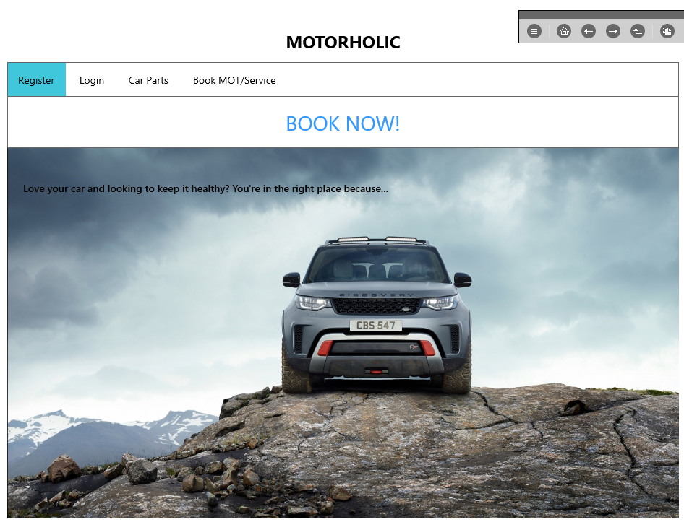

Figure 4. Mockplus Register Page

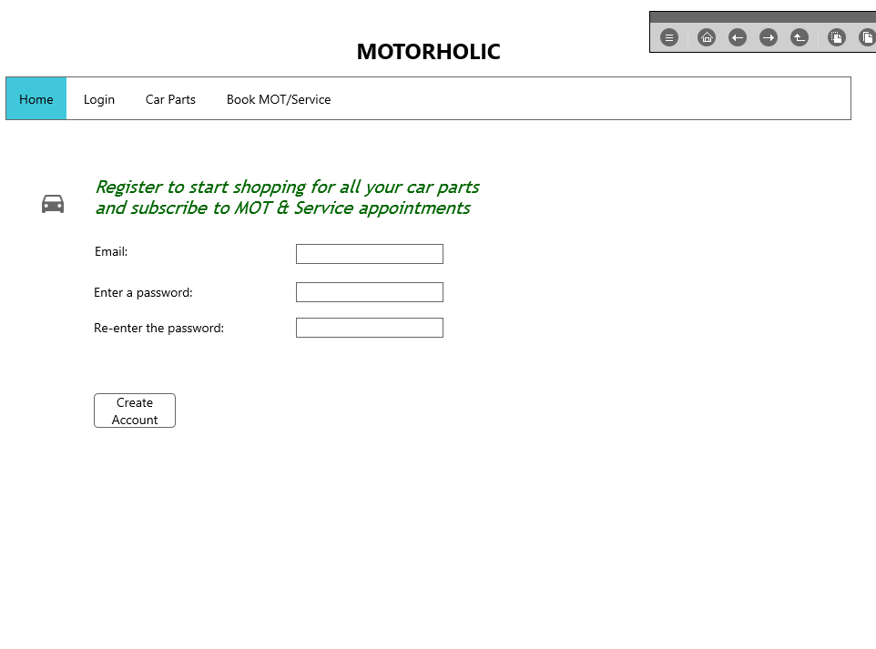

Figure 5. Mockplus Login Page

**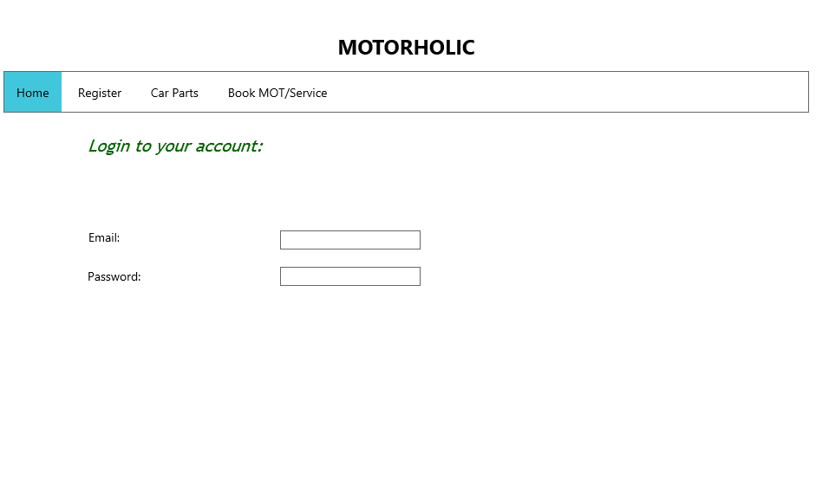**

6. Mockplus Blog Page

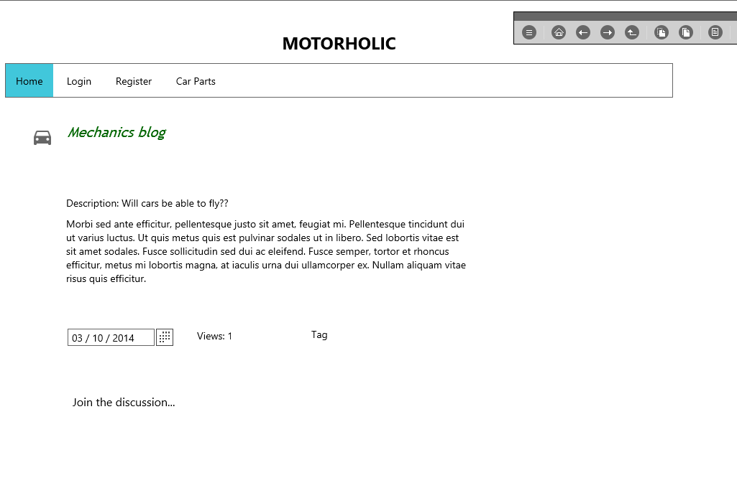

7. Mockplus Payment Page

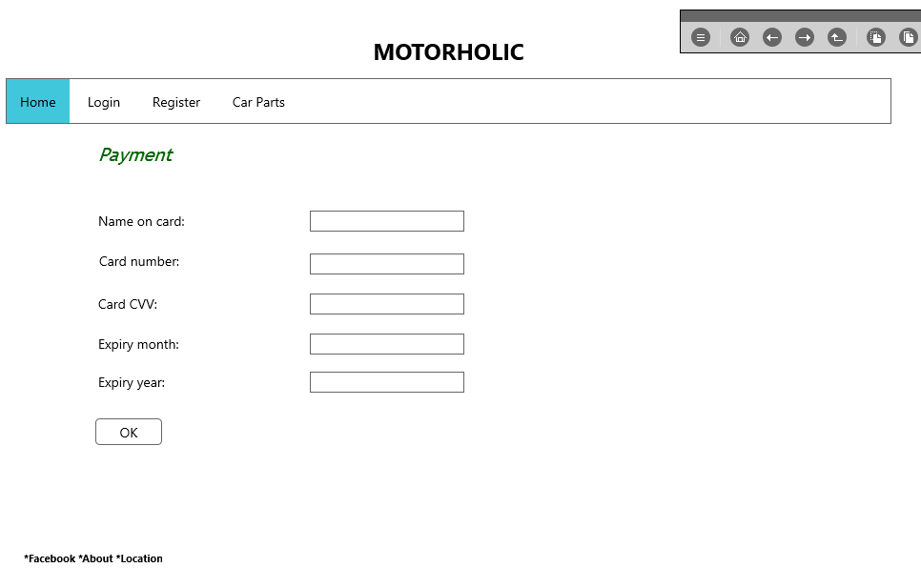

## Django Project Start Up

The very first steps to start the project was to create a directory (mkdir mechanic) and create a virtual environment. Once the virtual environment was activated Django was installed. Using the Django admin command a new project was created and the first few apps that were going to be worked on created as well. It made sense to start with the “home” and “accounts” app. The home app would be used for designing the navigation on the Welcome page and linking in some flat pages. The accounts app was hugely important because this was the app providing the user authentication across several Website pages.

Bootstrap features heavily in the Website and is a brilliant front-end framework to use to make Websites look professional. The Django Bootstrap forms was therefore also installed.

The settings.py file was updated so that Django could find the root templates directory. Additionally the home app was added to INSTALLED\_APPS at this stage.

1. Install Django under virtual environment

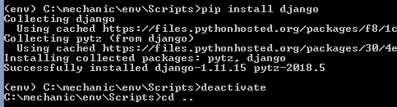

1. Start a new project with Django

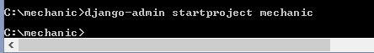

1. Check server

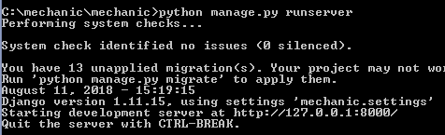

1. Start the first apps – home and accounts

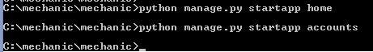

1. Bootstrap install (under virtual environment)

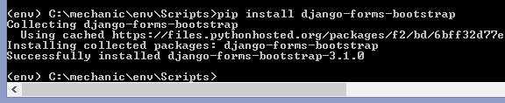

1. INSTALLED\_APPS

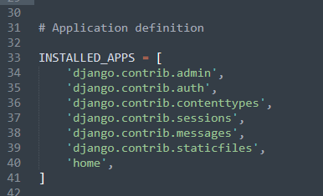

1. TEMPLATES update

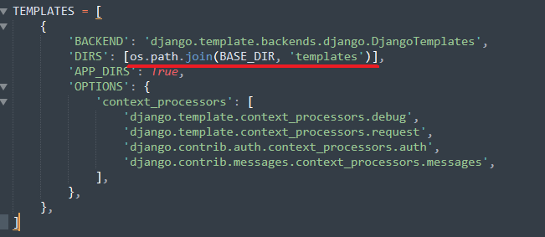

1. Browser view

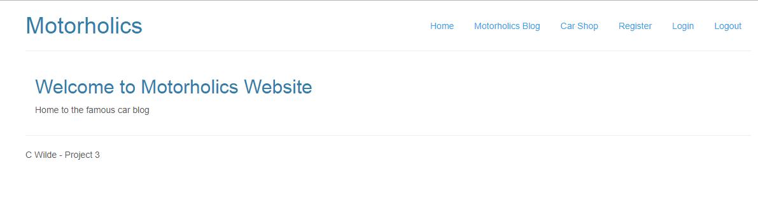

Figure 8. Django Project Layout

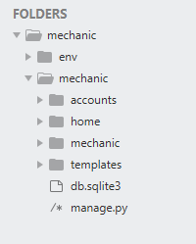

An index file was created so that the Welcome message to the site could be highlighted for the landing/base page

1. Index.html file – for Home app

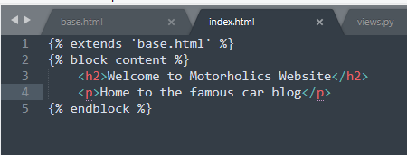

## The django Accounts app

It was decided that that registration would be via email and password validation. The username that most Websites asked for nowadays would be the email address. Therefore a “backend.py” file had to be created as well so the custom email authentication can be used instead of the default.

#### Models.py

The first step is to create the models and for the accounts app an AccountUserManager class was created first.

To create user objects Django should then refer back to the AccountUserManager class. Adding the User class achieved this. Under settings.py the standard AUTH\_USER\_MODEL was updated to reflect the accounts.User. This could then be used across the Website to authenticate users according to the AccountUserManager class in the models.py file. The AccountUserManager requires that the user’s user name is the email address of that person (username=email).

1. AccountUserManager class

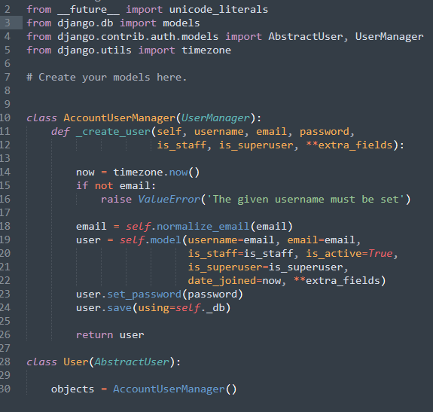

1. Settings.py

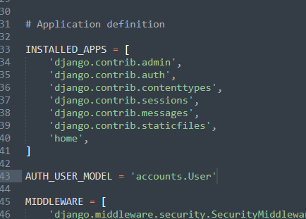

1. Backend.py file

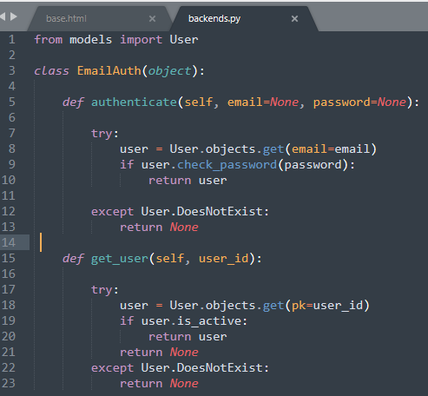

#### Views.py

The views.py file was then updated. This is the business logic to link the templates to the models created. The views.py file used the POST method which enables the HTTP communication between the user (client) and the server, in this case using the localhost.

Here is where the Register.html file could be referred to and so the next step was to create the Register.html file and save this file under the templates folder where eventually all html templates would reside.

1. Views.py file

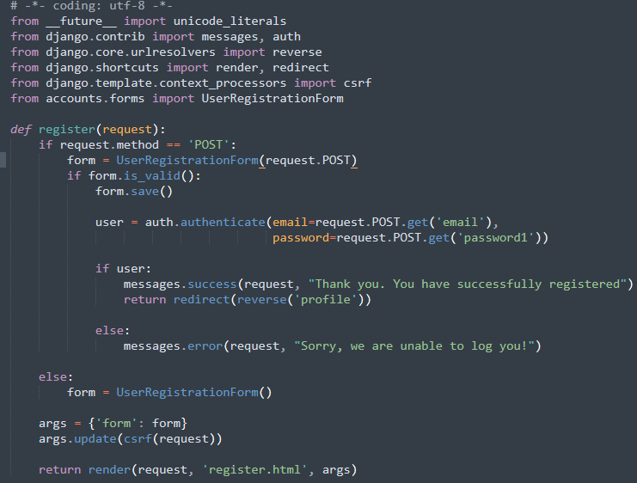

1. Register.html file

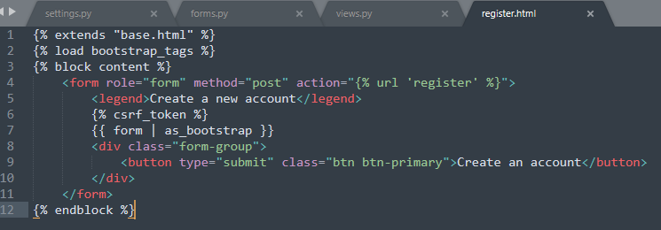

After adding the accounts app to the settings.py file (and additionally the Django bootstrap forms) the next step was to migrate the model changes which would update the SQLite database.

A profile.html file was then created for the logged in user. This would feedback to the user that they are logged in successfully on the Website. Note this was updated later once Stripe was installed and used to adjust the user profile.

After each html file was added the urls.py file was updated. This file tells Django how to look-up each file via it’s url.

1. Migrating the changes

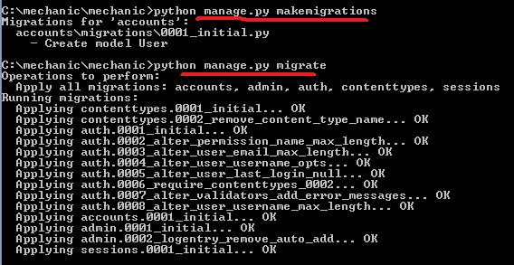

1. Profile.html file

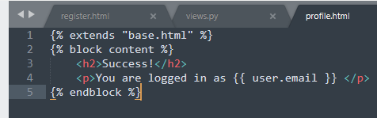

1. urls.py file

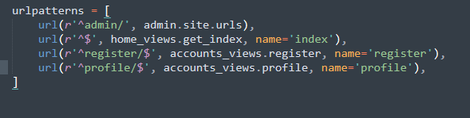

Next the views.py needed to be updated for both login/logout functions. The code was updated to reflect that if you have successfully logged in then you're redirected to the user profile page. To login a form was created and set under the form.py file. An html template was then added for the logged in view on the Website.

No new html template was required for the logout as this logic would just redirect back to the index view.

1. Login logic on view.py file

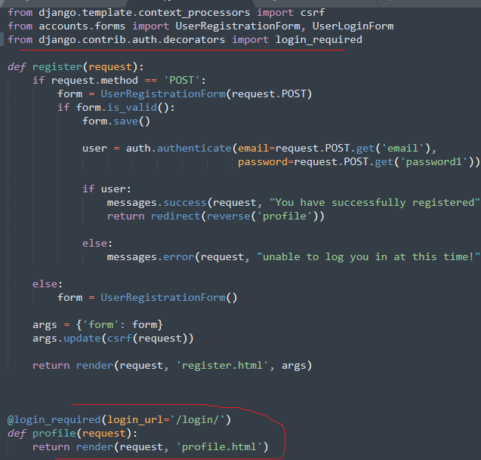

1. Login form (forms.py)

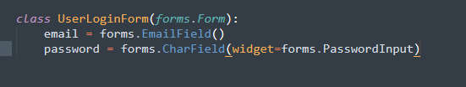

1. Logout logic (views.py)

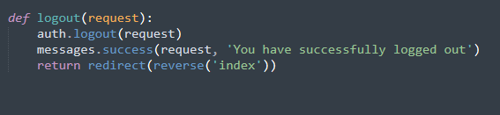

1. urls.py file

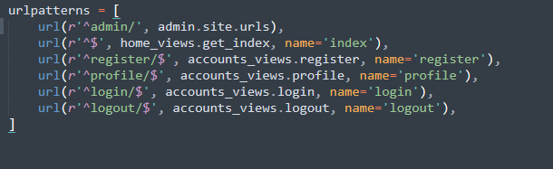

1. Updated base.html file with links

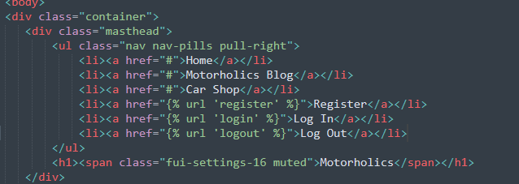

#### Stripe

Stripe was used for the subscription to the Motorholics blog/forum requirements.

Firstly using pip, Python’s install package command, Stripe was installed under the virtual environment. A Stripe account on the stripe Website was then created so that configurations on their API could be done.

1. Pip install Stripe (under virtual environment)

![Machine generated alternative text:
Admin cmd prompt 
(enu) install stripe 
30 Ilecting stripe 
Downloading https : //F 
løøz :uuuuuuuuuuuuuuuuuuuuuuuuuuuuuuuu: 215kB 416kB/s 
301 lecting requests python_uersion < "3 -W' (From stripe) 
Using cached https://FiIes-pythonhosted.org/packages/65/47/7eØ2164a2a3db5Øed6d8a6abId6d6Øb69c4c3FdF57a284257925dFc12bda/requests—2.19.1 
301 lecting (From requests python_uersion < "3 
• py3 
-py2 
—none—any. whI (208kB) 
. . whI 
Down loading https : //Files-pythonhosted.org/packages/16/IF/5Ød729cIØ4b21cIØ42aa5156Øda6141dIcab476ba7Ø15d92b2111c8db841/certiF i—2ø18 .8 .13—py2 whI 
løøz :uuuuuuuuuuuuuuuuuuuuuuuuuuuuuuuu: 153kB 1.3MB/s 
301 lecting urIIib3<I .24. .21 .1 (From requests python_uersion < "3 
Using cached https://FiIes-pythonhosted.org/packages/bd/c9/6Fdd99ØØ19Ø71a4a32a5e7cb78aId92c53851eF4F56F62a3486e6a7d8FFb/urIIib3—I.23—py2.py3—none—any.whI 
301 lecting chardet<3 .ø.2 (From requests python_uersion < "3 
Using cached https://FiIes-pythonhosted.org/packages/bc/a9/ØIFFebFb562e4274b6487b4bbIddec7ca55ec751Øb22e4c51F14Ø98443b8/chardet—3.Ø.4—py2.py3—none—any.whI 
301 lecting idna<2 (From requests python_uersion < "3 
Using cached https://FiIes-pythonhosted.org/packages/4b/2a/Ø276479a4b3caeb8a8cIaF2F8e4355746a97FabØ5a372e4a2c6a6b876165/idna—2.7—py2.py3—none—any.whI 
301 lecting -3.4; extra "security" (From requests python_uersion < "3 
Down loading https : . whI 
løøz :uuuuuuuuuuuuuuuuuuuuuuuuuuuuuuuu: 1.1MB 1.2MB/s 
301 lecting extra "security" (From requests python_uersion < "3 
Using cached https://FiIes-pythonhosted.org/packages/96/aF/9d29e6bd4Ø823Ø61aea2eØ574ccb2FcF72bFd613Øce53d32773ec375458c/pyOpenSSL—18.Ø.Ø—py2.py3—none—any.whI 
301 lecting cFFi! (From -3.4; extra python_uersion < "3 
Using cached https://Fi1es.pythonhosted.org/packages/3a/84/9d1bF29b212853Ø8?318696c38241a3aF65b33ea2edaabad11F26826ecF4/cFFi-1.11.5-cp2?-cp2?m-win32.wh1 
301 lecting enum34; python_uersion < "3" (From -3.4; extra python_uersion < "3 
Using cached https://FiIes-pythonhosted.org/packages/c5/db/e56e6b4bbac7c4aØ6deIc5Øde6FeIeF381ØØ18ae11732a5ØF15F62c7dØ5Ø/enum34—I.1.6—py2—none—any.whI 
301 lecting -4.1 (From -3.4; extra python_uersion < "3 
Using cached https://FiIes-pythonhosted.org/packages/67/4b/141a5811Ø4bIF6397bFa78ac9d43d8ad29a7ca43ea9Øa2d863Fe3Ø56e86a/six—I.11.Ø—py2.py3—none—any.whI 
301 lecting (From -3.4; extra python_uersion < "3 
Using cached https://FiIes-pythonhosted.org/packages/ea/cd/35485615F45F3Øa51Ø576FIa56dIeØa7ad7bd8ab5ed7cdc6ØØeF7cdØ6222/asnIcrypto—Ø.24.Ø—py2.py3—none—any.whI 
301 lecting ipaddress; python_uersion < "3" (From -3.4; extra python_uersion < "3 
Using cached https://FiIes-pythonhosted.org/packages/Fc/dØ/7Fc3a811eØIId4b388be48aØe381db8d99ØØ42dF54aa4eF4599a31d39853/ipaddress—I.Ø.22—py2.py3—none—any.whI 
301 lecting pycparser (From cFFi! -3.4; extra python_uersion < "3 
Installing collected packages: certifi- urIIib3. chardet. idna. pycparser. cFFi. enum34. six. asnlcrypto. ipaddress. cryptography. pyOpenSSL. requests. stripe 
(146 
(1. 
installed asnIcrypto—Ø.24.Ø certifi—2ø18.8.13 cFFi—I .11 .5 chardet—3.Ø.4 cryptography—2.3.I enum34—I.I.6 idna—2.7 ipaddress—l .ø.22 pyOpenSSL—18.Ø.Ø pycp 
(enu) ](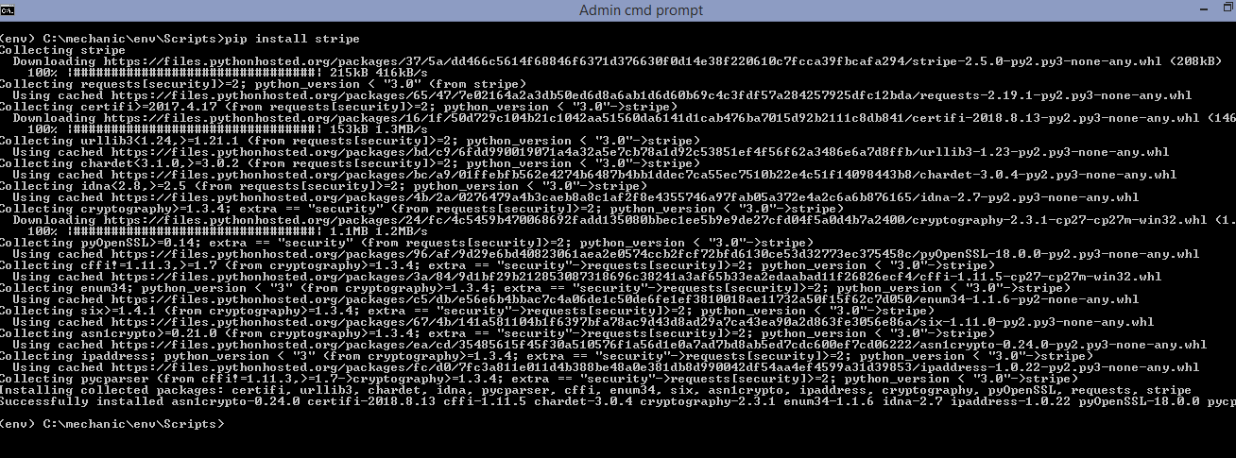)

1. Stripe Website

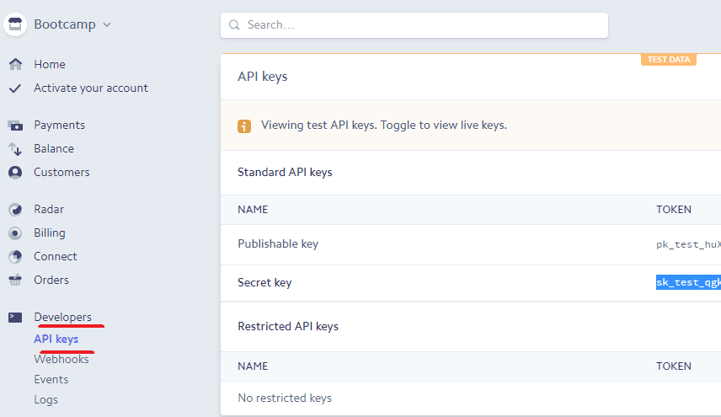

1. Updated settings.py file with Stripe keys

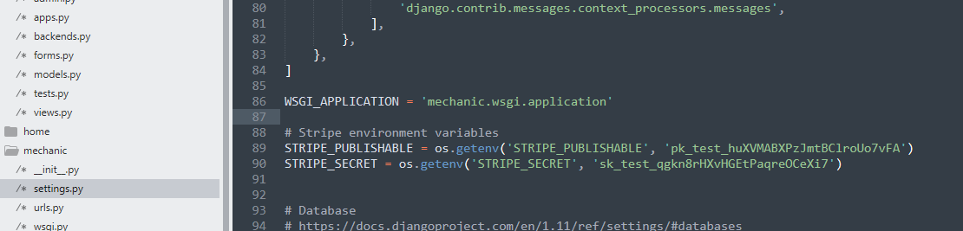

Stripe was added as an import to the top of the views.py file (import stripe) including arrow API which helps significantly with date formats. The forms.py was updated to reflect the relevant fields for payment such as credit\_card\_number, expiry\_month and stripe\_id.

Regarding the latter ‘stripe\_id’ in order to retain this the User class under the models.py file was updated:

Stripe\_id = models.CharField….

Again once all changes are made to the model a migration was done to update the database.

1. Forms.py file with fields to accommodate stripe payment

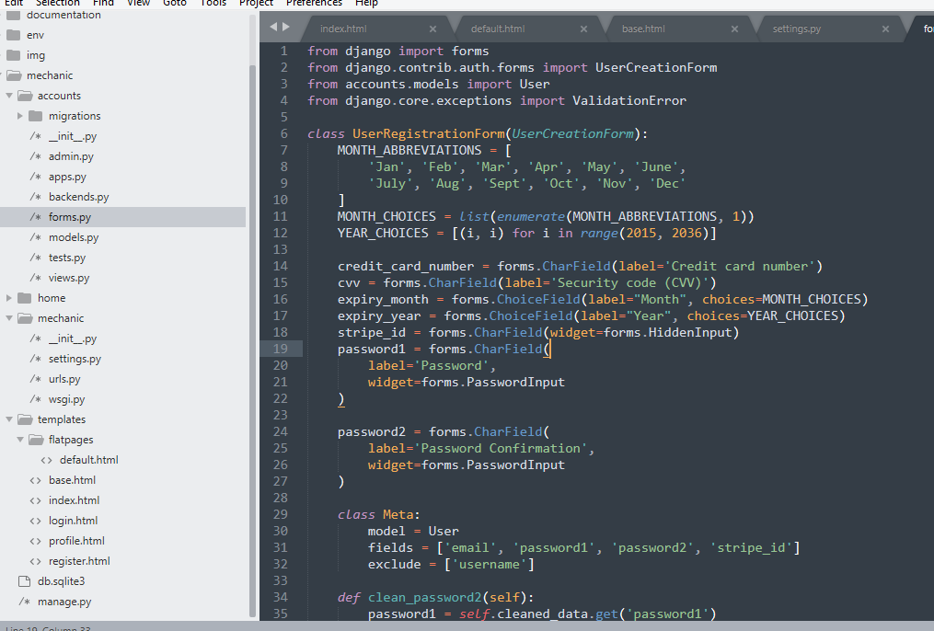

1. Models.py file updated to retain stripe id per user

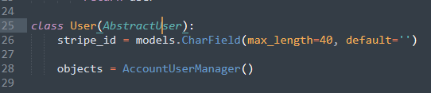

1. Migrate models.py changes

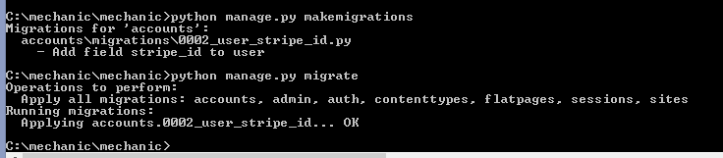

#### Stripe.js file

JavaScript was used to help validate the stripe payment form.

The .js file was saved under the “static” folder. A new folder was created simply called “js” and the stripe.js file stored under here.

Using JavaScript the validations confirmed that if the various fields (card number, expiry date, cvc) were completed and correct then a stripe token would be created and a stripe id returned otherwise the user would receive an error.

After this was established the register.html file was updated to link in the JavaScript code found in stripe.js by adding the “head\_js” block to the top of the file.

1. Stripe.js file

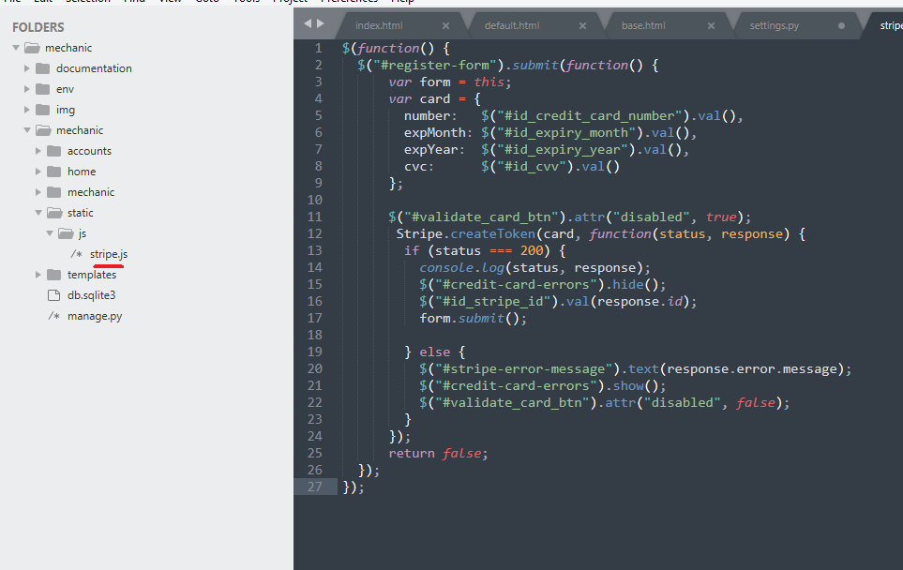

1. Register.html file with head\_js block

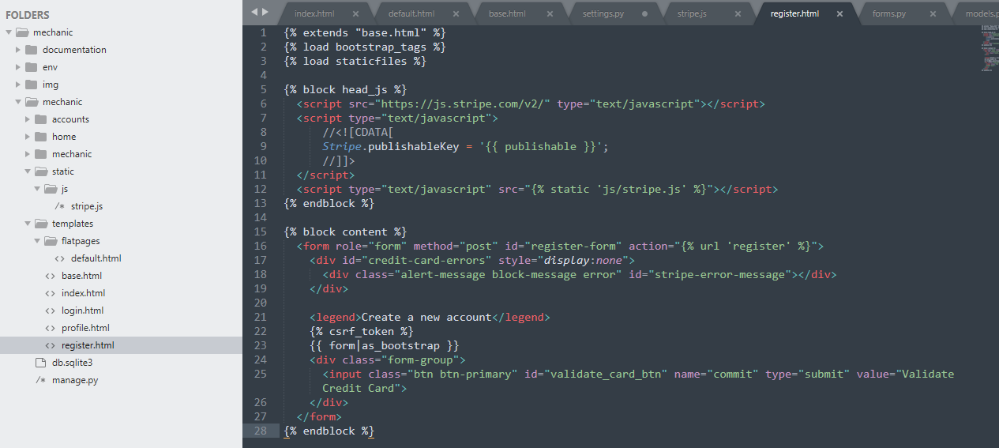

#### Subscribing Monthly

As mentioned the Website is to take a subscription from users who which to contribute to the Motorholics blog and forum.

In order to do this a Stripe “product” was created on the Stripe Website which was configured to take a £9.99 fee per month.

The views.py file was updated to reflect a POST method based on a valid form that obtains the email, card and the Stripe monthly product plan. The stripe\_id becomes the customer.id and a subscription based on adding 4 weeks. If validation fails then the users receives an error and feedback that the card was not accepted.

Note csrf is used to avoid malicious 3rd party intervention. The token code producing such a difficult random number that 3rd parties would not be able to guess and then dupe the user’s requested site with.

1. Stripe product plan

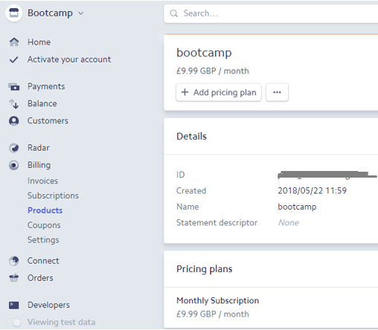

1. Updated views.py file

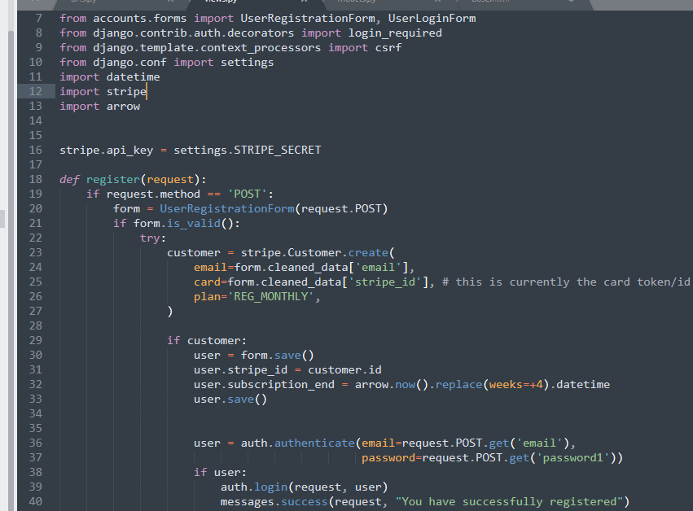

1. Updated User class (models.py)

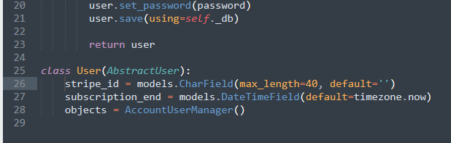

1. Migration of changes

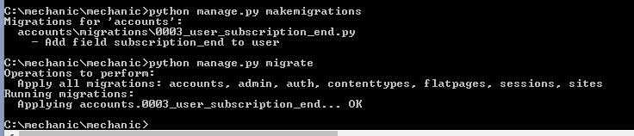

1. Customer monthly charges (Stripe Website)

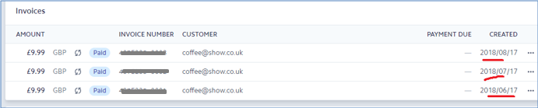

1. Registered accounts\_user view on SQLite database

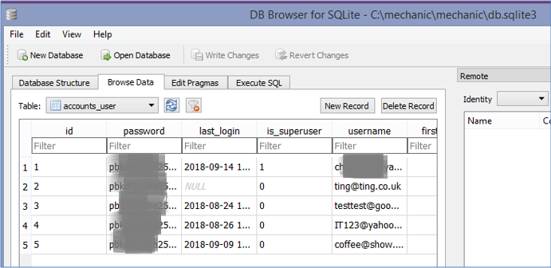

Lastly for users to cancel a subscription the views.py file was updated. In order to cancel the Stripe ID that was previously saved on registration is retrieved and then cancel subscription function entered based on the “at\_period\_end=True”. The urls.py and profile.html were subsequently updated.

So now once users log in they will not see the register or login tabs.

Once users logout however the Register and Login tabs will appear on the Website.

1. Updated views.py for cancellation

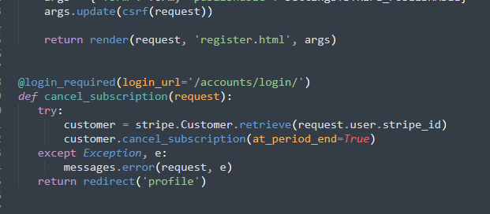

1. Updated urls.py file

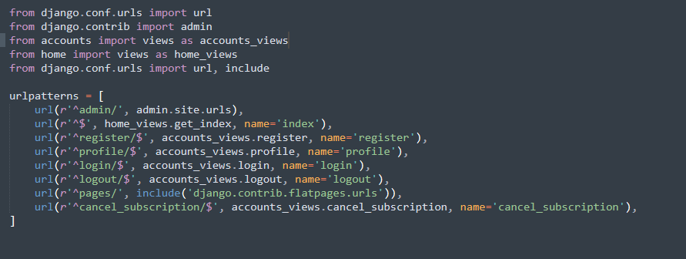

1. Updated profile.html file

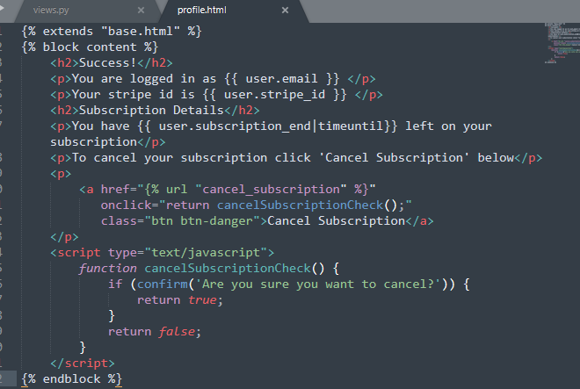

## flatpages

Flatpages was used for the “about us” page. Flat HTML pages are displayed as they are stored which in this case is the Django Admin site. This is an easy way to simply format pages such as about us, security notifications, certain policies etc.

Since these are created on the Django Admin site the first step was to create a superuser for the Admin login.

The settings.py file was updated so that the Django flatpages feature was set under the INSTALLED\_APPS and the SITE\_ID set once the correct ID sequence was checked under SQLite database. Due to these changes a migration was then done. The middleware was then updated for the flatpages routing.

The flatpage default html template was saved under a new flatpages folder in the templates project root folder. Once the extend base.html code was added to the top the flatpage formatting was applied across all the pages.

1. Flatpages folder structure

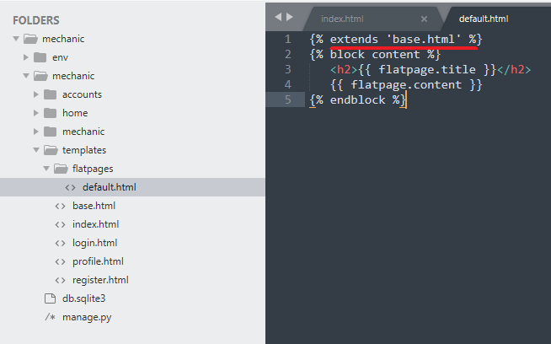

Then it was just a matter of adding the flatpage URL to the urls.py file and then new flatpages could be created quite easily on the Django Admin site.

1. INSTALLED\_APPS update for Flatpages

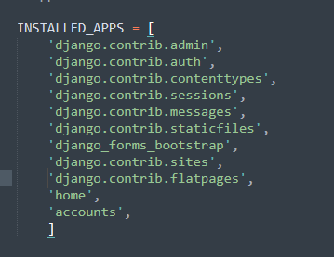

1. SITE\_ID added

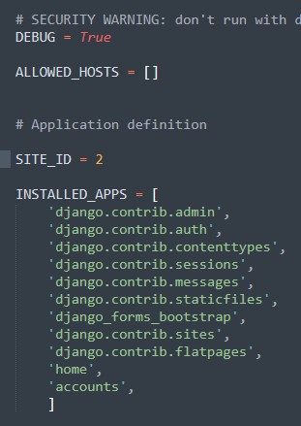

1. Migrate changes – flatpages

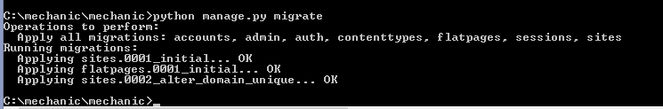

1. Middleware updated

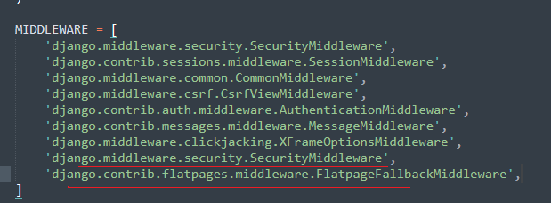

1. Update urls.py file – flatpages

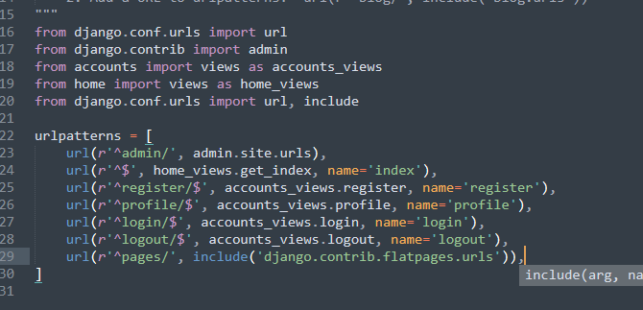

1. Django Admin site – adding About us page

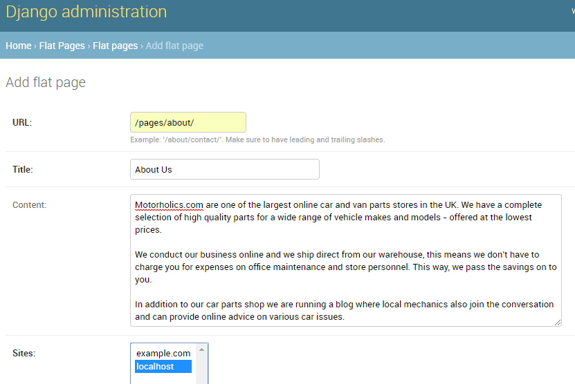

## The django blog app

The Motorholics Website is to feature a blog that mechanics can access as the administrators and start writing on various car topics. If a user is interested in contributing then they will need to subscribe and become part of the Motorholics “team”. They will not be permitted to start topics however will be allow to contribute to the blogs.

The first step is to use the Django startproject command.

The model was created first and once done then the views and templates could be focused on.

Update blog\models.py with Post class

As mentioned any user wishing to post will need to be an authorised user, so the model needed to specify the custom auth user settings that had previously been created via the accounts app.

In this case the accounts.User.

In order for the mechanics (staff) to add a new topic the Post model was registered on the admin.py file. Once done the Post object appeared on the Django Admin site ready for a new post to be added.

1. Model.py – blog

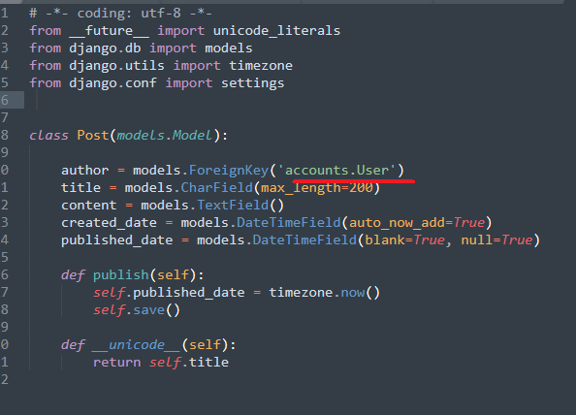

1. Migrate the changes – blog

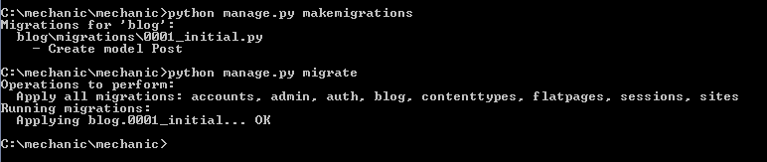

1. Registering Post on the admin.py file

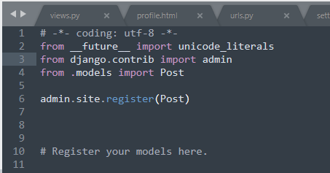

1. Django Admin site – Adding a new Post

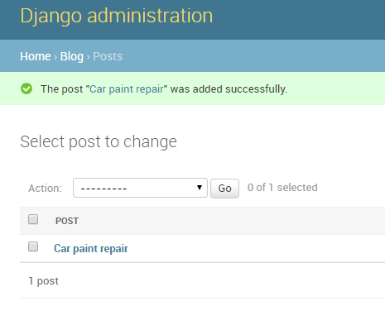

#### Post List and Post Detail views

A post list and post detail view was added.

For this the views.py file was updated with new car post html files. The urls.py file was updated so Django would be able to find the correct path to the views.

The blog urls were added to the blog app urls.py file this time and then referred back using the ‘include’ wording in the root urls.py file.

In order to link the detail view back to the relevant blog the PK (primary key) was used from the database. This was set in the post\_detail view and results shown the carpostdetail.html template.

If a post ID is not found then the Website displays a 404 error.

1. Views.py file – blog

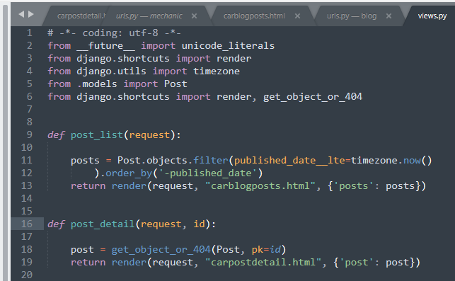

1. Carblogpost.html file with PK reference

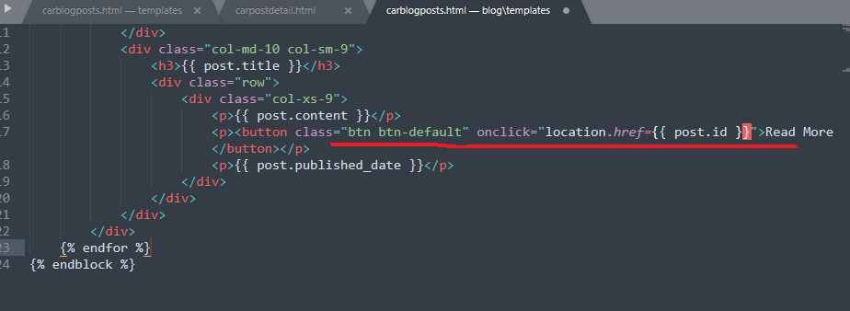

Additionally a view counter, date and tags were added to the blog lists. After this the changes were migrated.

1. Blog list example

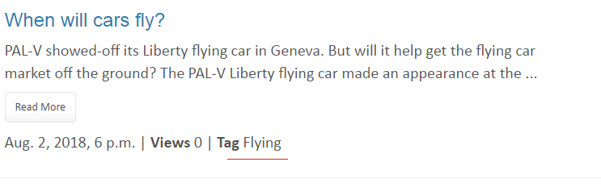

#### Disqus and Images

Disqus is a global communication platform that can be added to Django projects. This was added to the blog for global discussions under a particular existing thread. In order to add another thread to a topic the New Post would still need to be clicked (for authorized members).

Images were added since they made the site posts more eye catching and helped to highlight a topic.

The DISQUS\_WEBSITE\_SHORTNAME was added to the settings.py file.

Additionally the blog app was added to the INSTALLED\_APPS under the settings.py file.

The carpostdetail.html file was updated with disqus tags: {{% load disqus\_tags %}.

1. Disqus Website account

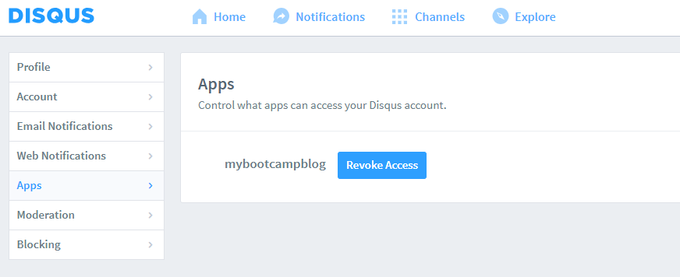

1. Disqus pip installation

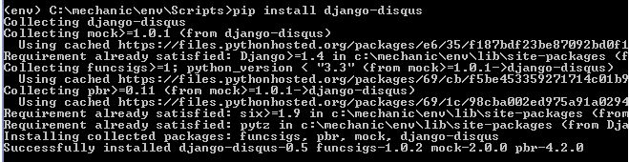

1. Settings.py file updated – blog

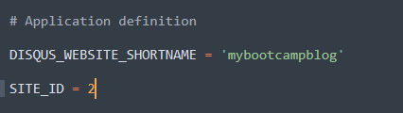

1. DISQUS\_WEBSITE\_SHORTNAME



Images was added with the help of Pillow installation, the Python imaging library.

Once migrated a media folder was created and the MEDIA\_ROOT folder was set under the settings.py file. This is so images can be uploaded dynamically by users on the Website (as opposed to the stored images under the static folder).

1. Pip Pillow installation (under virtual environment)

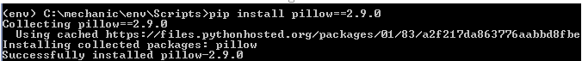

1. Updated settings.py – blog media path

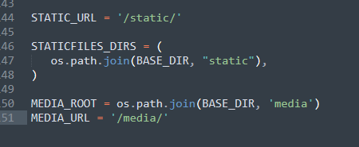

#### New Post Form

A post form was designed for the user once they clicked on New Post: 

The forms.py file was therefore updated and a new view created (new\_post). This was then directed back to the new car post form.

The POST method was again used for the new post mechanism. This then redirects the user back to the post details so they can see the results.

1. New post form – blog (with imaging enabled)

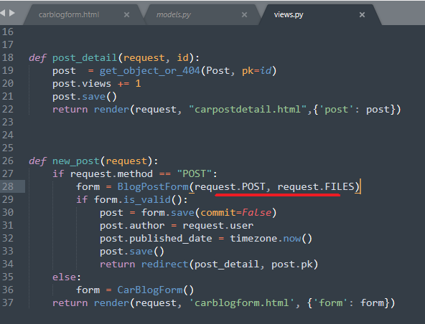

1. New post form view – blog

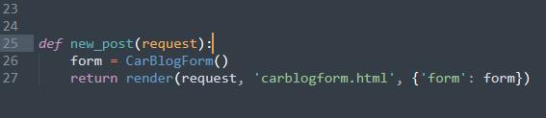

1. Making use of the POST method again

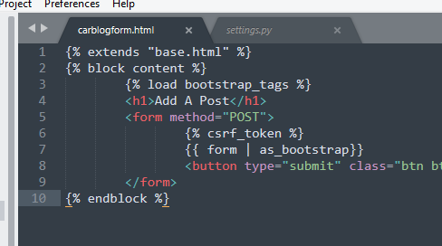

1. Non authorized user

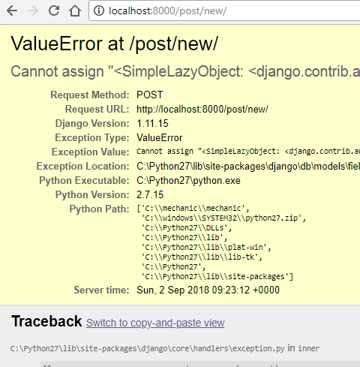

Editing was very similar to the post new view. First the object is retrieved or a 404 error shown. Then the CarBlogForm used to make an updated and POST this. The user is then again directed back to the post detail.

1. Views.py edit view - blog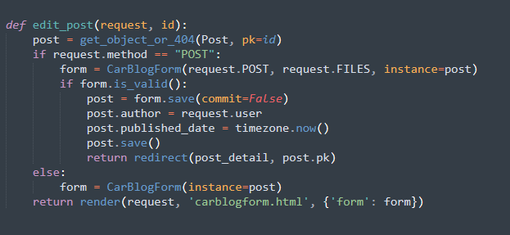
2. Website view

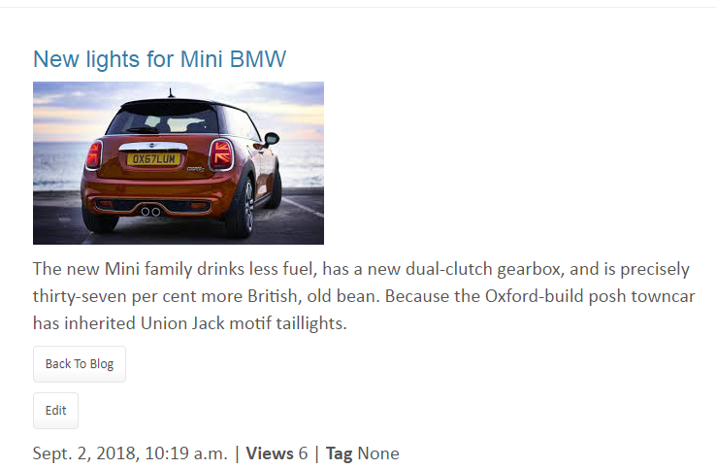

## The django Thread (forum) app

The forum app was created for users to connect to mechanics and ask questions on various car topics. Only subscribing members can response to a post and only staff can add a new subject similar to the Blog app. Registered users can also add a vote to certain subject so mechanics can see some results on their advice. For fun a further feature was added with JavaScript for users to toggle through the Auto Express best car 2018 list.

The forum also made use of Font Awesome and Tinymce.

#### Models.py – Forum

Once the new app was added under the settings.py file the first step was to add the models for the app. Three classes were created: Subject, Thread and Post.

Each model had fields added and a migration was done. As mentioned only registered users can respond to a discussion so the user field was set to the AUTH\_USER\_MODEL.

Once the migrations were done the three models were registered on the admin.py. The staff can now add new Forum subjects.

1. Models.py – Forum

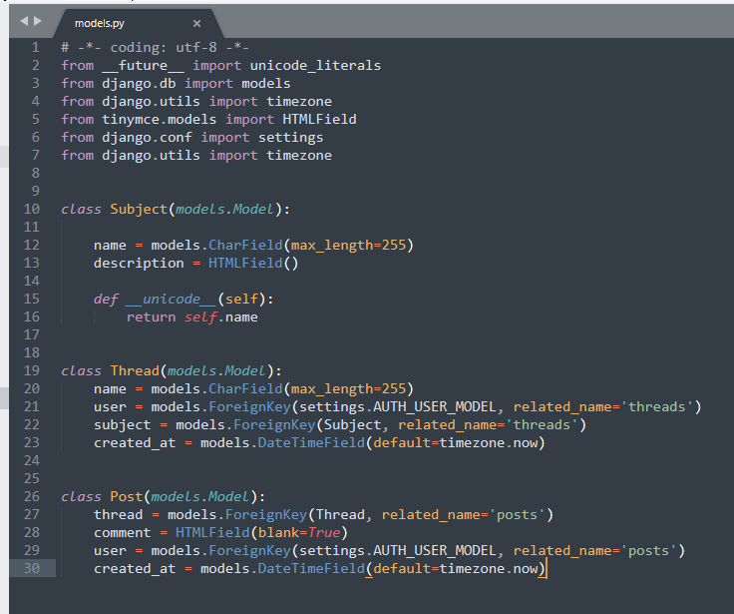

1. Migrate the changes – Forum

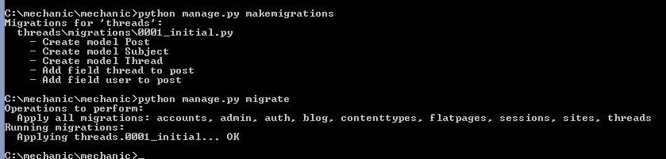

#### HTML files and thread extras

Two html files were created.

Carforum.html (this will list all the Subjects)

Carthreads.html (this will list a particular subject with its threads)

For user to add a new thread they need to be registered i.e. logged in. The @login\_required was therefore used on the views.py to ensure only logged in users are adding threads.

Under the apps template folder a new folder was created called forum which houses all the html files for the forum.

A new folder was created call threadextras which kept a new file called thread\_extras.py. This file contained the filtering for all the threads, for example get\_total\_subject\_posts.

1. HTML files – Forum

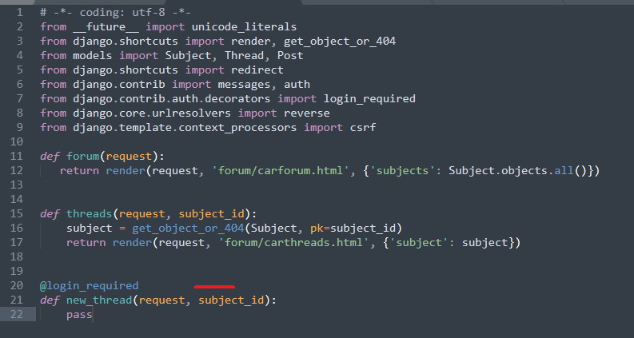

1. Thread\_extras.py filtering – Forum

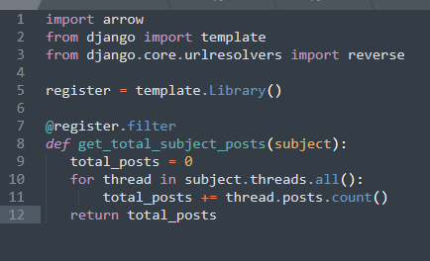

#### Views.py file – Forum

The views.py consisted of forum (directing to main forum html file), threads (thread lists), creating new threads, adding new posts to a thread, editing, saving and deleting functions.

For all editing, saving and deleting the @login\_required was again used so only registered users could contribute. The {% if user.is\_authenticated %} method and {% if post.user == user or user.is\_staff %} method were both used for authenticating on the forum app. The POST feature was used for the ‘new’ item functions which is the same process as the blog app.

Two forms were designed for adding a new thread or a new post to a thread. These were then referred to in the views.py file.

1. Views.py file new thread – Forum

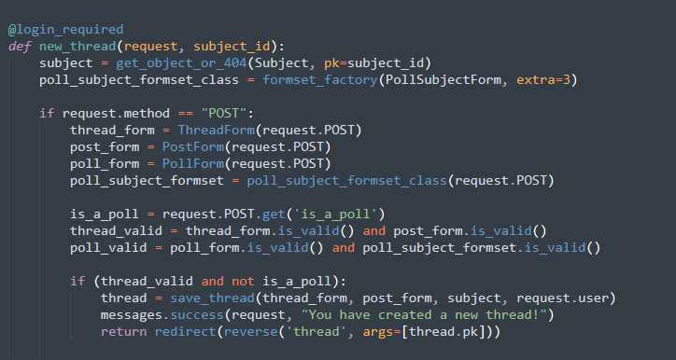

1. Forms.py – Forum

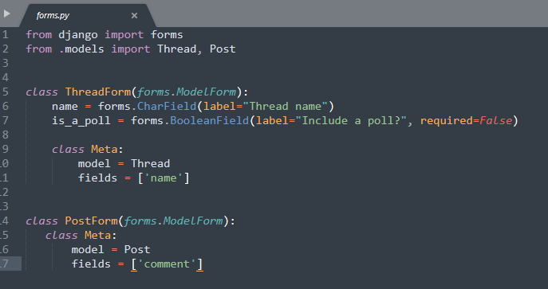

#### New poll app and design

A new poll app was also created to be used in conjunction with the forum/thread app.

Once a user adds a new thread they can include a poll to obtain voting on certain subject from users. Via the thread\_extras.py file the calculations on how many users voted and it’s percentage. Font Awesome and Tinymce made the look of the voting and threads even better.

The Auto Express JavaScript addition was added for fun for car enthusiasts.

1. Models.py file – Polls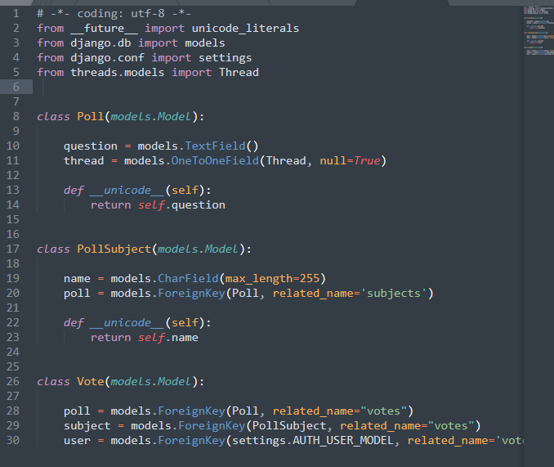
2. Forms.py view – Forum (vote feature added)

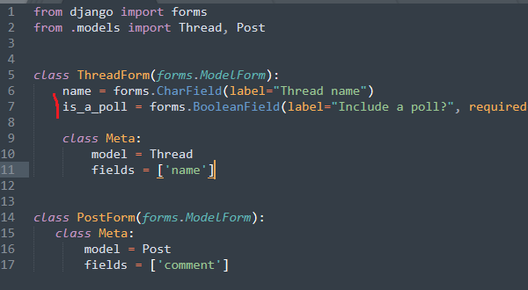

To hide the voting buttons once someone votes update the thread\_extras.py file. This ensures they can't vote again.

1. Thread\_extras.py – Voting

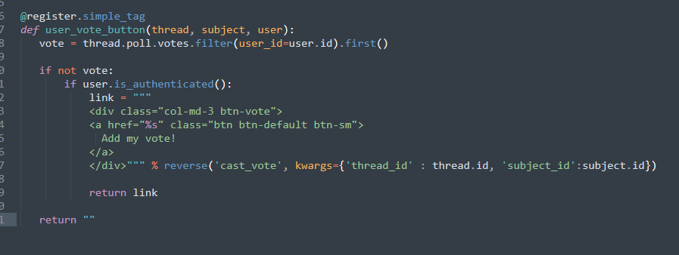

The use of Tinymce was use for the voting fields.

1. Poll feature

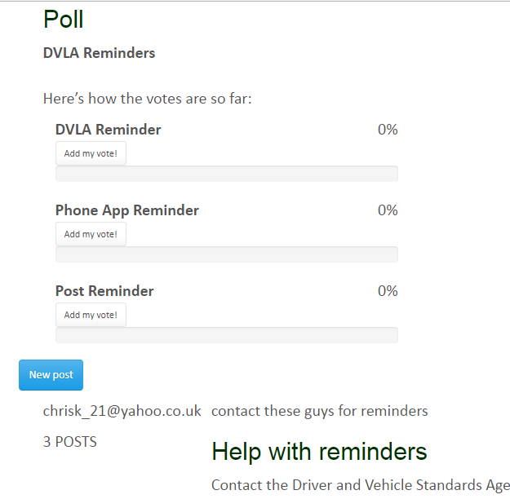

Glyphicons was used to design a spinning pencil to make the Website a bit more eye-grabbing.

1. Glyphicon pencil css – forum

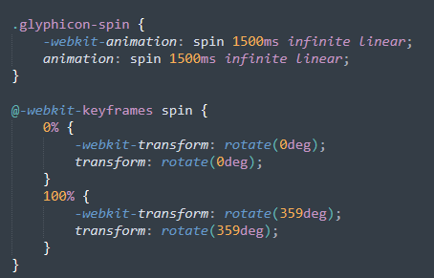

1. Glyphicon pencil html – forum



The mechanics.css file was saved under the static folder. The JavaScript for the Auto Express feature was also saved under the static folder.

1. myScript.js – forum

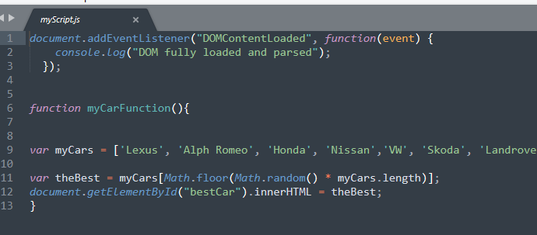

1. Auto Express JavaScript feature

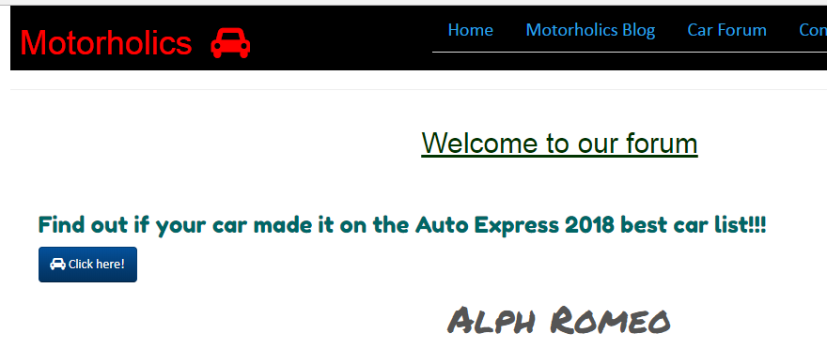

## motorholics project testing

The below table summarizes the testing results whilst working on the Django project.

|  |
| --- |
| JavaScript – Auto Express feature |
| Tested in Code Pen |
| Python tests – Home app |
| test URL      Used assertTemplateUsed() to check template is the one that’s actually being used  render\_to\_response  to check output from URL and ensure nothing else is affecting it |
| Python tests – Threads (forum) app |
| Testing the threads real data but to test subjects and alike we need to run database tests (so tests are based on data) |
| Database testing |
| First create fixtures folder in app  Then run command per below to run a dump of data from the test database    This produces the Json format file output:    To make it work also need to collect my user data from accounts app    Output of user data    Updated threads test |
| Testing via one object class |
| Updated home app tests using one test class for all:    Error –    Added the below that were missing on imports  from django.core.urlresolvers import resolve  from home.views import get\_index    Corrected –    Complete home pages tests: |
| Model tests |
| No need to tests models generally so did quick test on the custom user setup under accounts app |
| Form Validation |
| 1. Validation for unfilled forms   First test for form that is filled out    Result –    Now with incomplete fields      With incorrect matching passwords    Indentation error    Fixed    Missing password      Invalid card |
| Threads app form |
| Result –    No name entered for thread |
| Further URL tests |
| Blog url          Negative test on forum URL:  Updated to INCORRECT URL …..    Result – |

## motorholics – the complete product

The Motorholics Website was designed so it was viewed as clean and professional – a place where users can receive valuable car advice and support.

The below pictures show each section of the Website and the results.

#### The Home Page

The home page features a cover image with a short introduction to the Website. Unlike some other car Websites that are overloaded with information this was kept nice and tiny.

The About Us button featured a small icon using Font Awesome and this was carried over to most of the other buttons on the Website as consistent branding.

The Motorholics name was highlighted in the Bootstrap Navbar and a car icon added. The rest of the menu items on the Navbar lay neatly to the left via the nav class “"nav nav-tabs pull-right”.

When a user is logged in the Navbar shows “Logout” on menu.

However if a user is not logged in the Navbar updates to show the Logon facility.

Figure 9. Home Page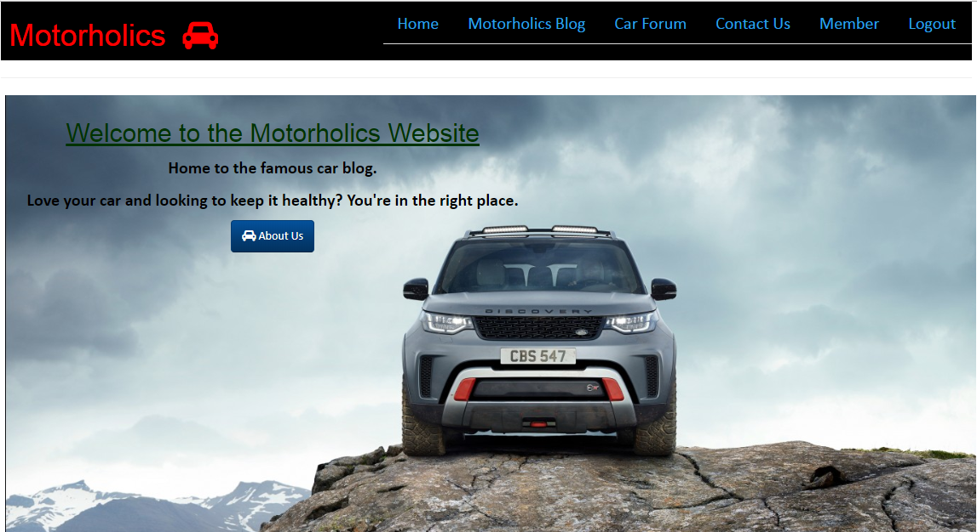

Figure 10. Navbar Login/Logout



#### The Blog Page

The Blog page lists various car subjects and an M brand logo on the left. If a user is logged in they will be able to see the “New Post” button as well as the Read More button.

Under the Read More button the registered users can either edit the post or navigate back to the blog list. Here is where Disqus was also added for discussions on a global platform.

Figure 11. The Blog Page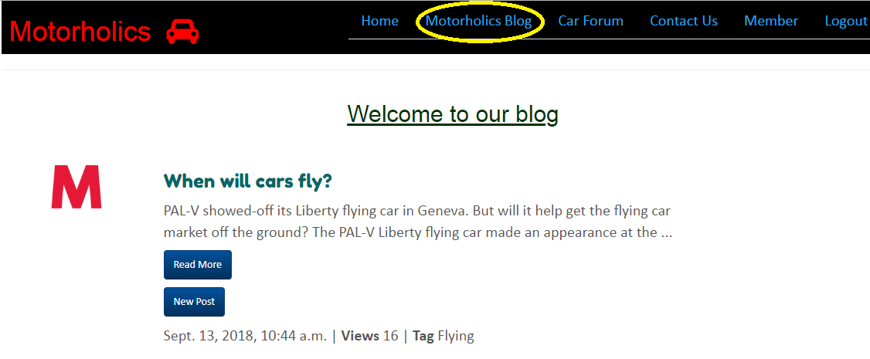

Figure 12. New Post – Blog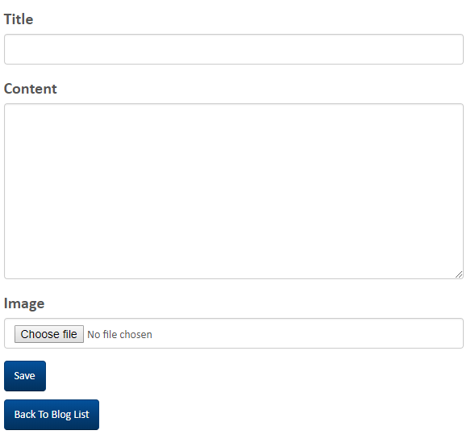

Adding a new post to a subject allows you to add a new title and content plus add any image you like. The image is saved to the /media/ project folder.

Figure 13. Read More – Blog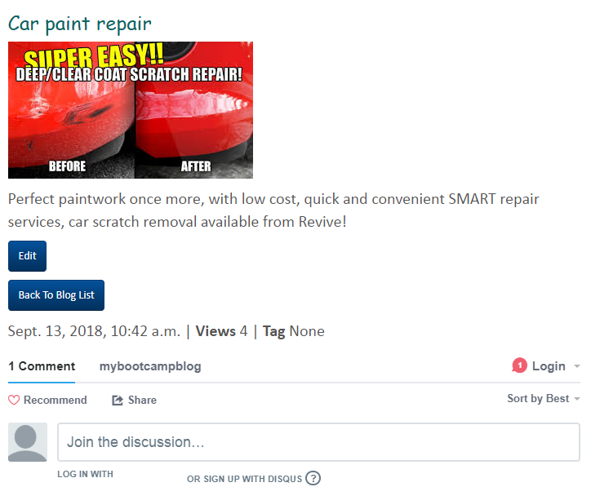

Figure 14. Editing a thread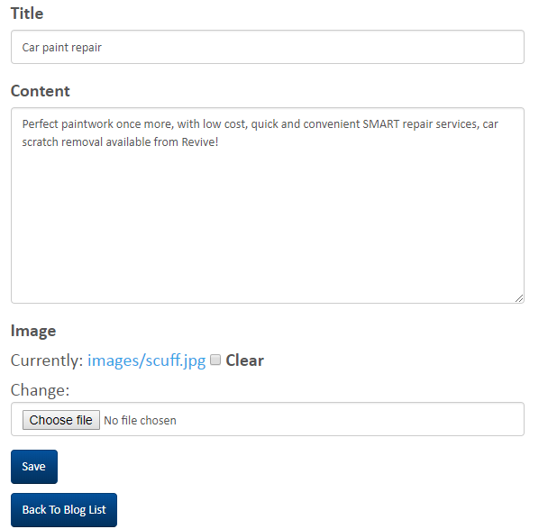

Once a user clicks on Edit they can modify the post’s title and content. They can also delete an existing image and add a new one then save the changes.

#### The Forum Page

The Motorholics car forum listed all the threads to specific subjects started by the staff – in this case the mechanics. Registered users who are logged in can see the New Thread button once they click on a subject.

The new thread form and voting mechanism both used Tinymce.

Figure 15. The Car Forum Page

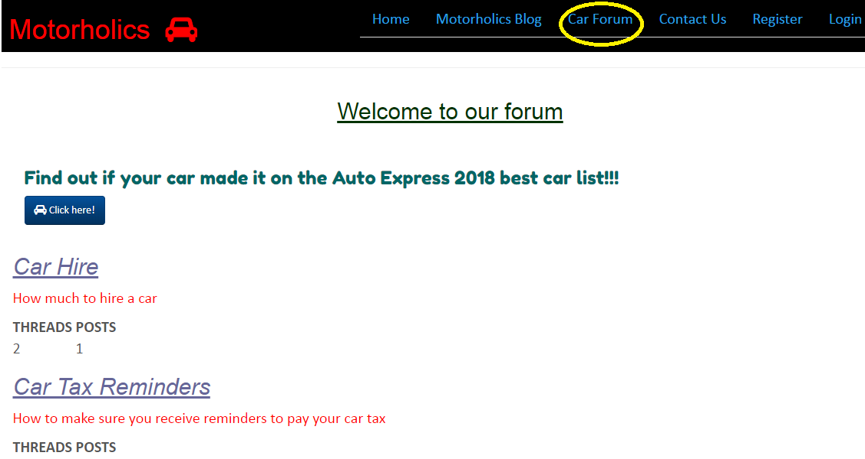

Figure 16. New Thread – Forum

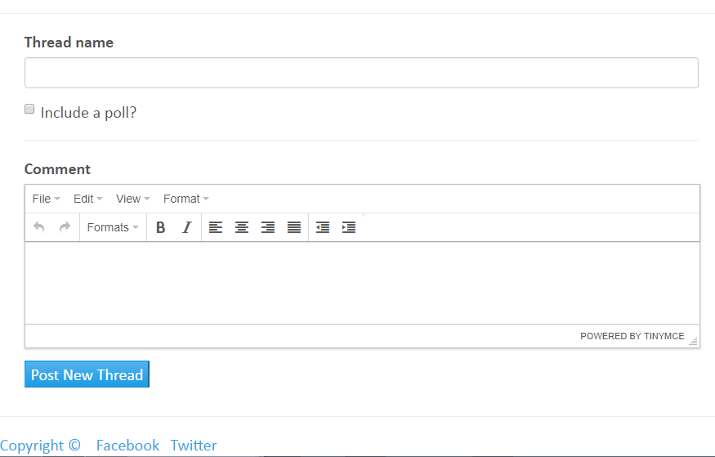

Figure 17. Voting option

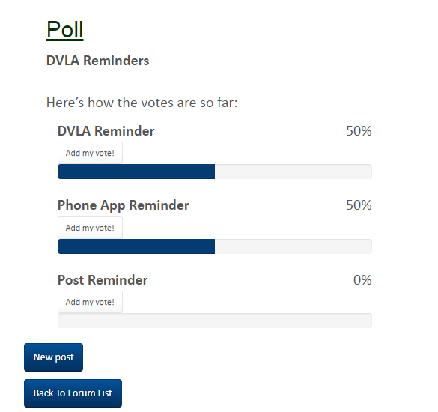

The Auto Express function lists random cars that made it to the best car 2018 list.

Figure 18. Best Car 2018 JavaScript



The “Contact Us” page was created using Flatpages

Figure 19. Contact Us page

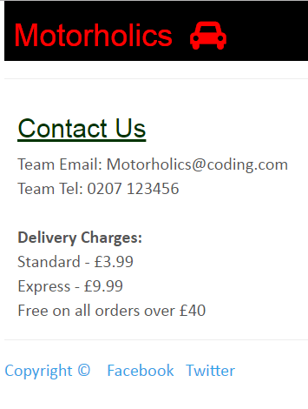

#### Registration

Once of the most important features was the user registration. This was designed using a custom user authentication model and meant that users registered with their email address.

Stripe was used for payment processing.

Figure 20. Registration page

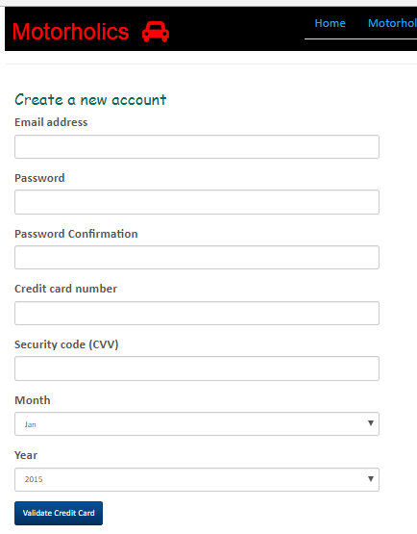

#### Login/Logout pages

Users logged in using their email address and password. Once logged in they can then contribution to the blog and forum.

Under the Member tab users can view the account details.

Once logged out the user is presented with a green stripe on the home page confirming they have been logged out.

Figure 21. Login page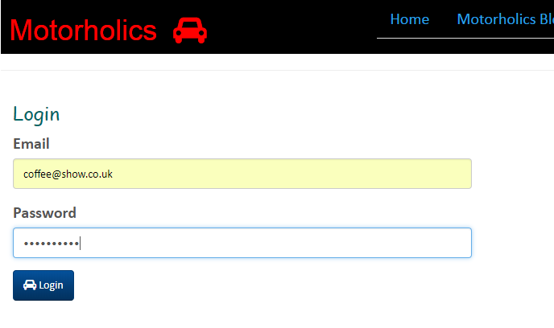

Figure 22. Logout notification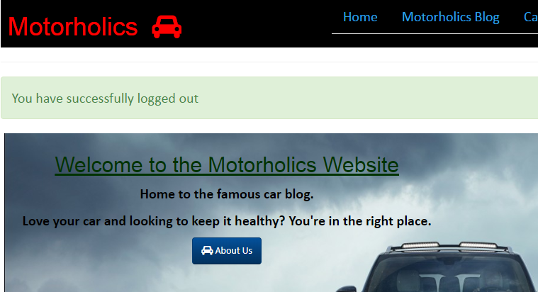

Figure 23. User registration

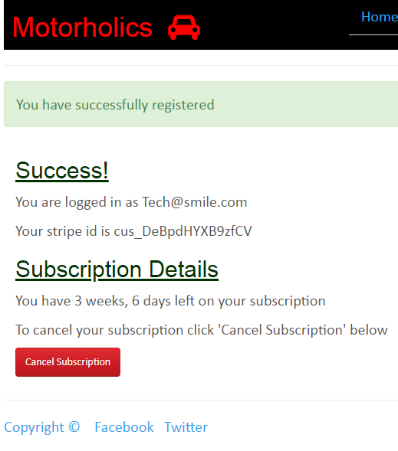

#### Conclusion

The Django project was easy to create and design. The architecture of how models, views, templates and urls etc fit together are logical.

The collaboration of some software interfaces such as Tinymce, Flatpages, Disqus etc made some components that would have been otherwise more time consuming to construct very simple. This leaves the developer more time to focus on the coding!

Bootstrap was again used to design eloquent Navbars and other designs and possibly is my favorite framework throughout the course.

## reusable apps

As the last step to the Motorholics project the individual applications of significance to the Website were repackaged to make them reusable. This saves re-inventing the wheel and for developers saves a large amount of time.

Per below the following apps were made resusable from the Motorholics Website:

-Accounts

-Blog

-Threads (Forum)

-Polls (repackaged but to be used in conjunction with the Blog app)

An overview of the main steps taken to repackage each app is highlighted below:

## Reusable app 1 – blog

The models.py file was edited so that AUTH\_USER\_MODEL is used (the default User model so this can be used across different projects):

1. Previous Models.py - Blog

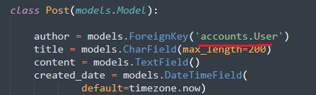

2. New Models.py - Blog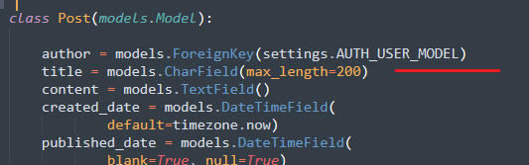

Next the blog app urls.py file was updated.

The word ‘blog’ was removed since it can be added to in URLs when reusing the app.

3. Urls.py file - Blog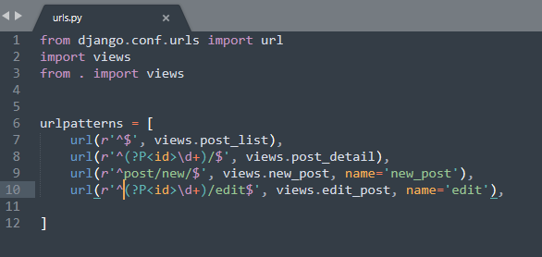

The following was then created

* A new template folder
* A new static folder
* A new css folder and image folder under static folder. These will contain the jpg and css files

The layout therefore took the following structure:

Blog>template> (html files)

Blog>static>css>mechanic.css

Blog>static>images>logo.jpg

4. Blog app project structure

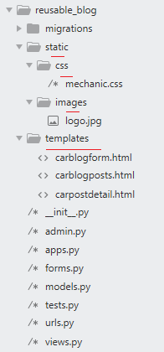

A new folder was then created on the directory called ‘reusable\_blog\_app’ and the blog app placed inside renaming to ‘reusable\_blog’

FILES

Various files then had to be saved in order to provide setup details and instructions on how to use the app. The subsequent files were created:

* README.rst (instructions on how to install and use the app)
* LICENSE file
* MANIFEST.in (instructions on the setup.py includes .jpg)
* setup.py (setup Python package and how to use it)

Renaming

Essentially some content in files required updates since there were references to ‘blog’ when the repackaged app is now named ‘reusable\_blog’.

5. Migration files updated - Blog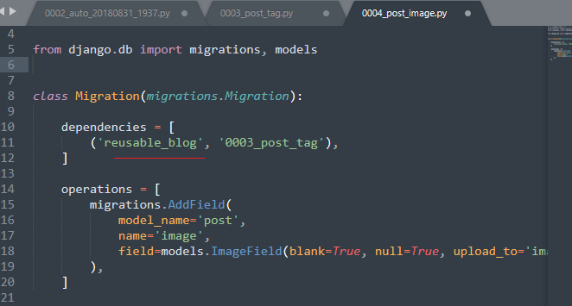

## Reusable app 2 – threads

Per the Blog app the AUTH\_USER\_MODEL was set under models.py file.

No updates were done on the urls.py file as this was fine.

The folder structure was however updated. A template folder was added under Threads and the forum folder (that contained all the forum html templates) saved inside.

Threads>templates>forum>(html files)

The following folders were created:

* A new template folder
* A new static folder
* A new css folder and js folder for tinymce and custom js file

1. Threads app project structure

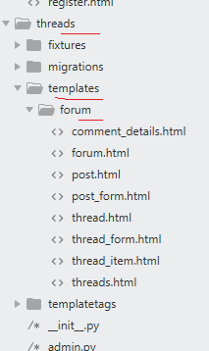

1. Threads app – static folder structure

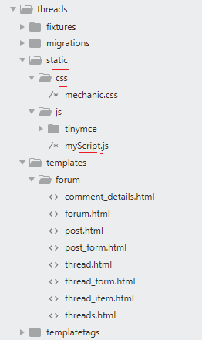

A new folder was then created on the directory called ‘reusable\_threads\_app’ and the threads app placed inside renaming to ‘reusable\_threads’.

FILES

Various files then had to be saved in order to provide setup details and instructions on how to use the app. The subsequent files were created:

* README.rst (instructions on how to install and use the app)
* LICENSE
* MANIFEST.in (instructions on the setup.py includes .js)
* setup.py (setup Python package and how to use it)

No specific reference to threads app were found in files so nothing had to be re-worded.

## Reusable app 3 – accounts

For the accounts app the folder structure was updated and the following folders were created.

* A new template folder created
* A new static folder and css folder for the Mechanics css file created
* A new js folder for stripe.js file created

The project structure therefore took the following form:

accounts>template> (html files)

accounts>static>css>mechanic.css

accounts>static>js>stripe.js

1. Accounts app project structure

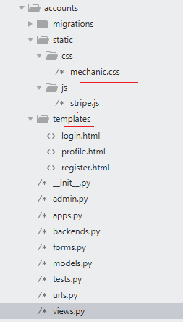

A new urls.py file was also create to be saved in the accounts app and was updated per below.

1. urls.py file – Accounts

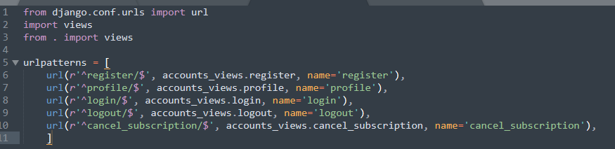

A new folder was then created on the directory called ‘reusable\_accounts\_app’ and the accounts app placed inside renaming to ‘reusable\_accounts’.

FILES

Various files then had to be saved in order to provide setup details and instructions on how to use the app. The subsequent files were created:

* README.rst (instructions on how to install and use the app)
* LICENSE
* MANIFEST.in (instructions on the setup.py includes .js)
* setup.py (setup Python package and how to use it)

The migrations files from accounts app were then updated referencing reusable\_accounts.

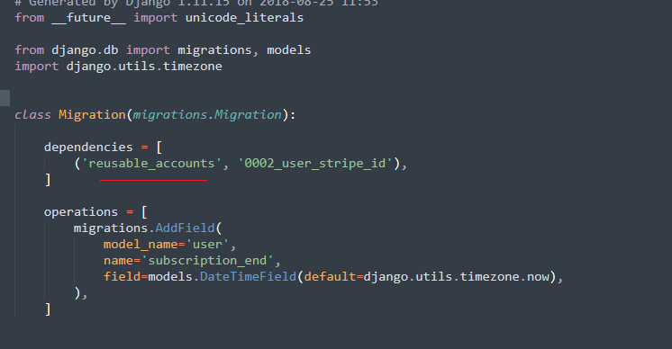

## Reusable app 3 – polls

The polls app models.py is available for re-use within the app.

This is to be used in conjunction with the threads app if required

A new new folder reusable\_polls\_app was created and the polls app placed inside renaming to ‘reusable\_polls’.

The polls app migration files were updated to reference the reusable\_threads app that needs to be downloaded first. The polls app works together with threads app.

1. Migration files – polls app

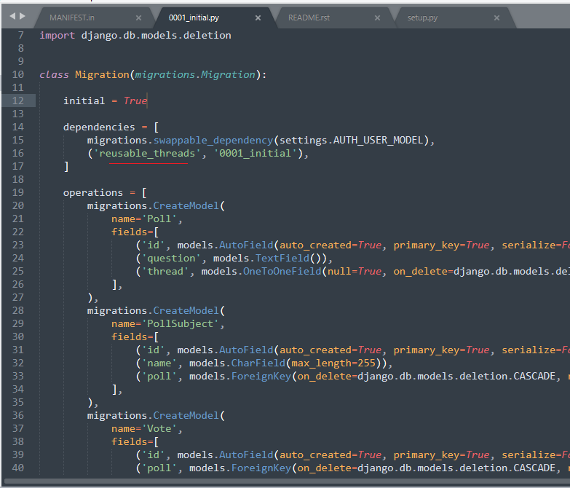

FILES

Various files then had to be saved in order to provide setup details and instructions on how to use the app. The subsequent files were created:

* README.rst (instructions on how to install and use the app and also special note that this app is to be used with the threads app so it makes sense to download the threads app first)
* LICENSE
* MANIFEST.in (instructions on the setup.py \*app to be used in conjunction with the threads app if required)
* setup.py (setup Python package and how to use it)

## Project Deployment Steps

Below is the completed folder layout – both ‘requirements’ and ‘settings’ folders have been added.

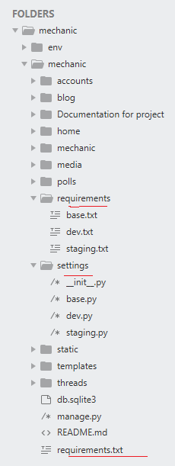

**STEP 1**

**In the “settings” folder the following files were added in the next few steps:**

The MEDIA\_ROOT was commented out since this does not work well with Heroku unfortunately.

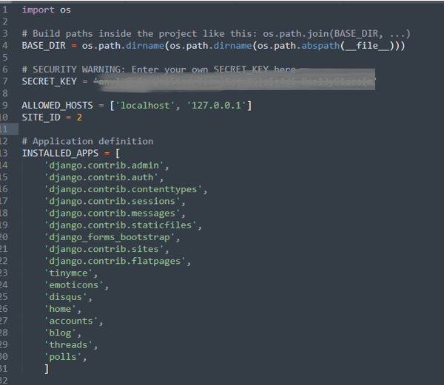

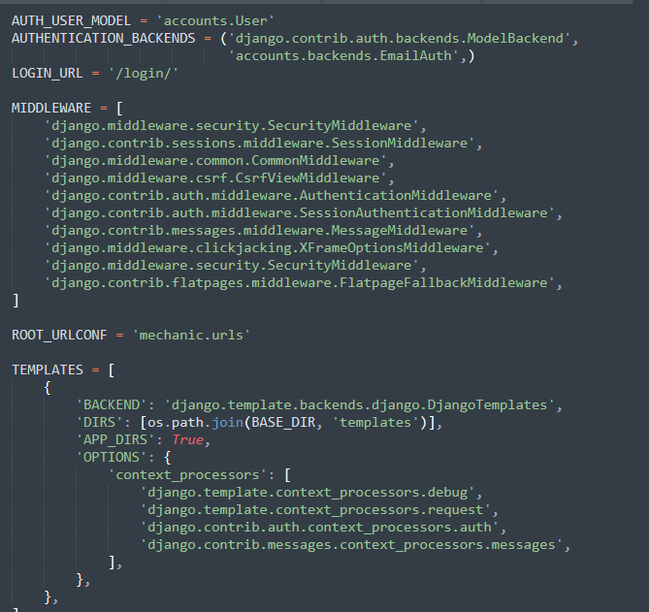

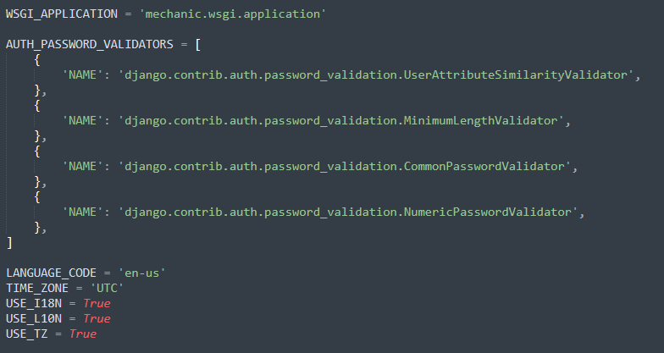

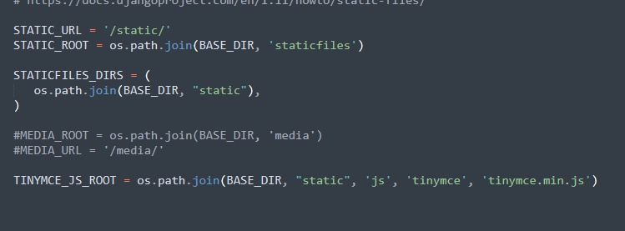

**STEP 2**

The dev.py file added (including the Disqus and middleware).

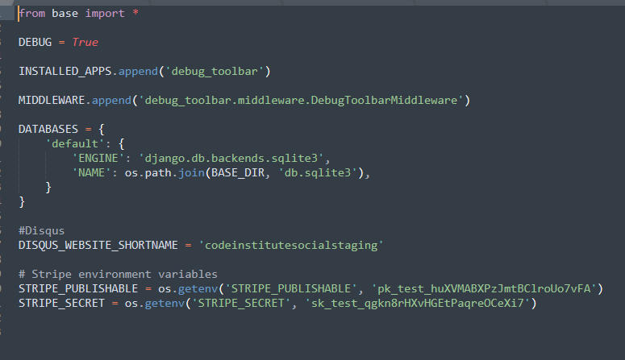

**STEP 3**

The staging.py was created (including stripe variables).

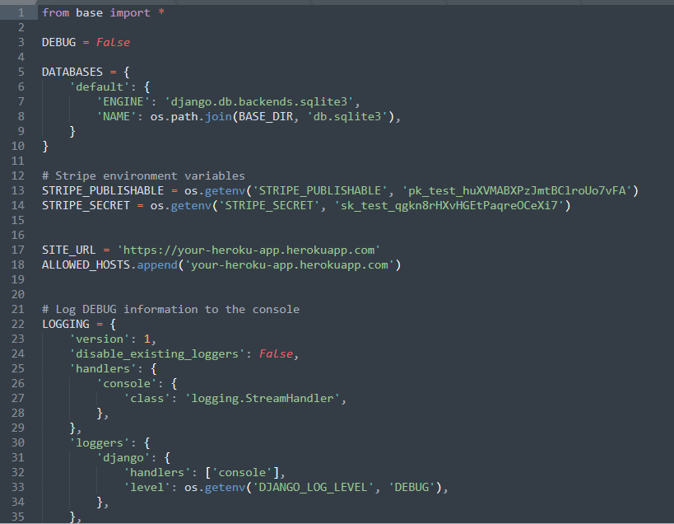

At this stage an \_\_init\_\_.py file was added.

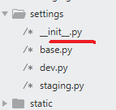

**STEP 4**

**In the “requirements” folder the following files were added in the next few steps:**

base.txt – all the requirements Heroku needs to run the app which the versions that have been tested during development.

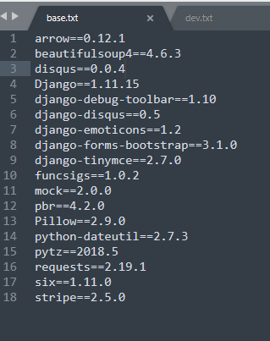

**STEP 5**

The dev.txt contained the reference to the base.txt requirements but also the debug toolbar from Django – this will only be run in the dev environment.

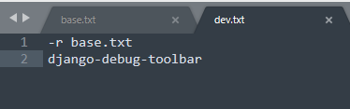

**STEP 6**

The staging.txt file refers back to the base requirements as well but also includes the Python mysql component since a SQL database is used for this app.

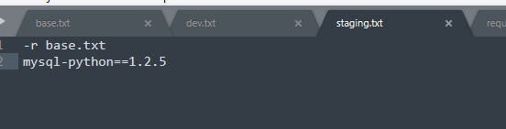

**STEP 7**

Heroku looks for a requirements file so the requirements.txt was created under the project root.

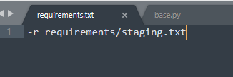

**STEP 8 – GIT BASH: DEPLOY TO GITHUB REPO**

Once on Github a new repository was created called mechanic (the preference was to have the same name as the project to keep things consistent):

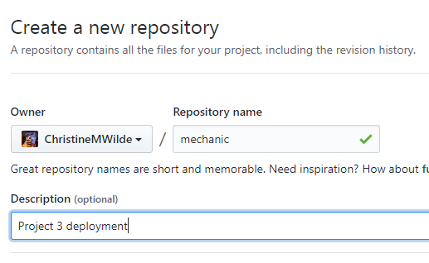

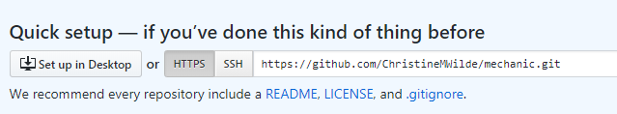

**STEP 9 – GIT BASH COMMANDS**

The following commands where run to deploy the project to the new GitHub repository.

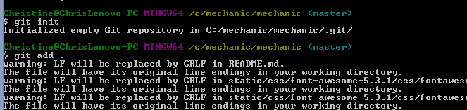



Committing the deployment.

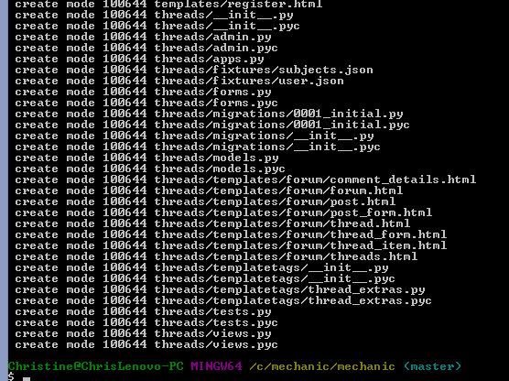

Files are now uploaded to Github (a .gitignore file was initiated at a later stage – please see last step).

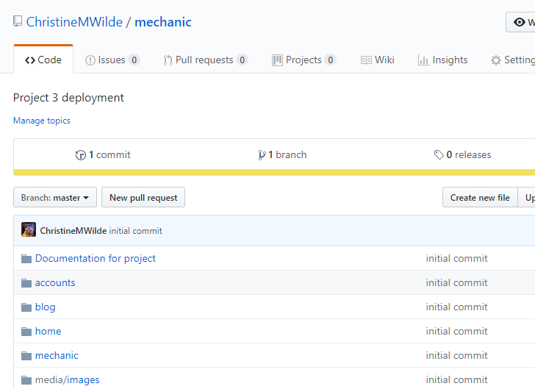

**STEP 10**

A new Heroku app was created taking on the Website name Motorholics.

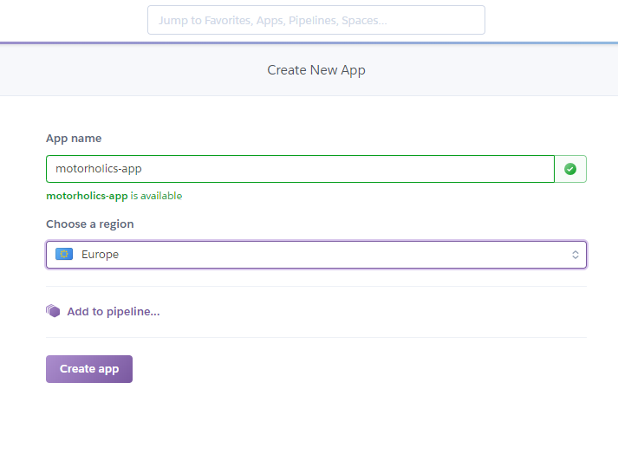

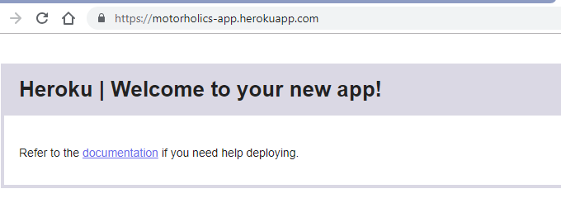

**STEP 11**

The staging.py was updated with the Heroku app name.

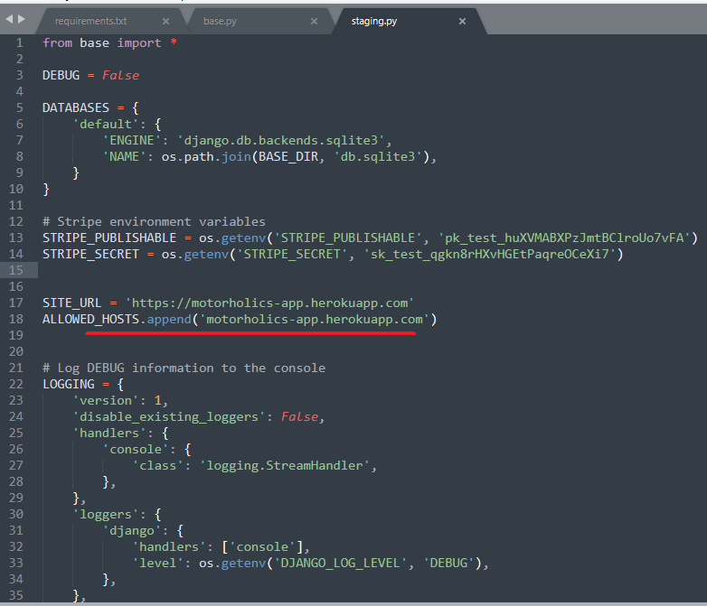

**STEP 12**

Gunicorn was added to base.txt.

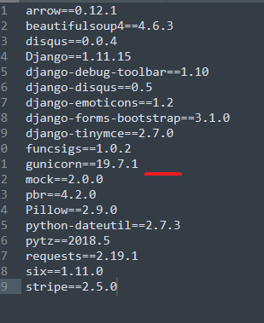

**STEP 13**

A Procfile was then added to command Heroku to run the web command and use gunicorn.

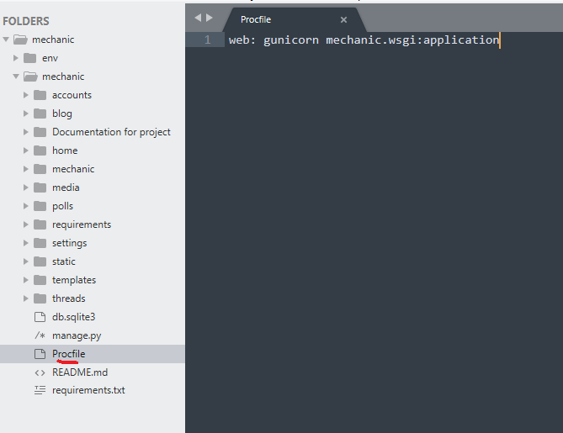

**STEP 14**

The runtime.txt was added – Python 2.7.15 is used.

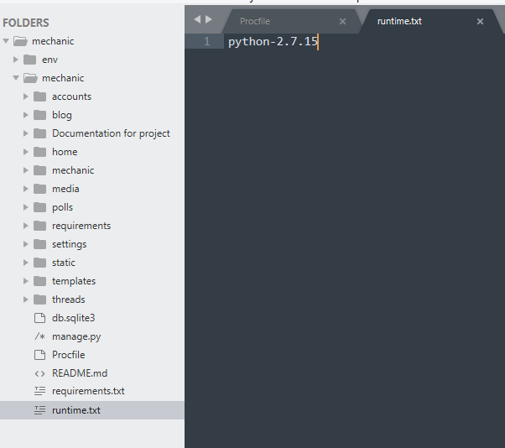

Python

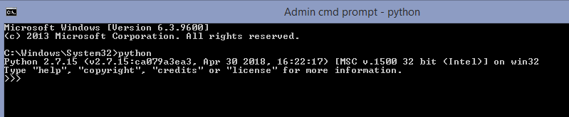

**STEP 15**

Since the app is run off a Windows machine a Procfile.local was created to help host on Heroku by using the Python manage.py runserver command.

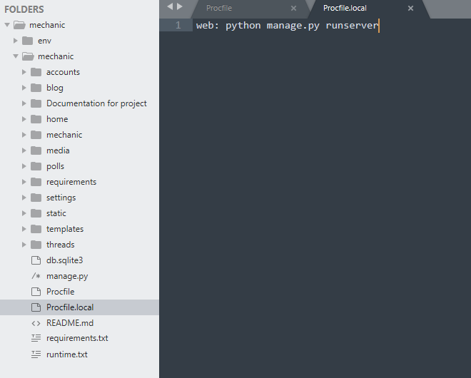

**STEP 16**

On git bash the dev settings were set.

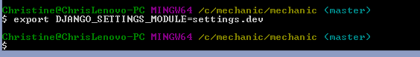

**STEP 17**

Next is to test that Heroku runs locally :

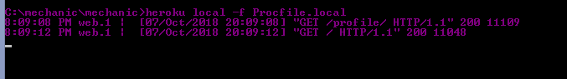

**STEP 18**

On the Heroku dashboard under Deployment the Heroku app was connected to GitHub.

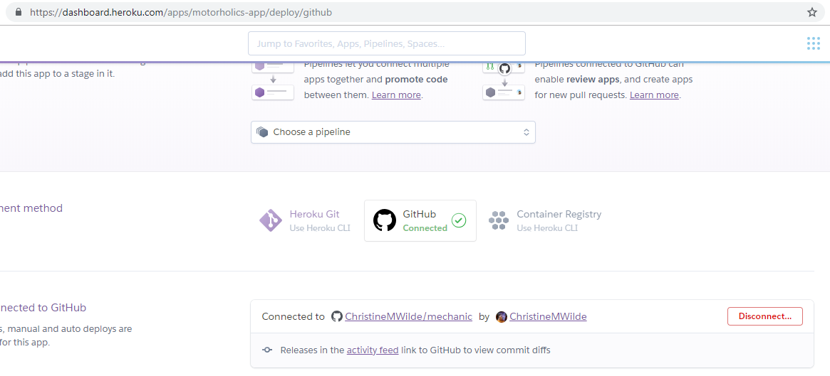

Auto deploys was switched on.

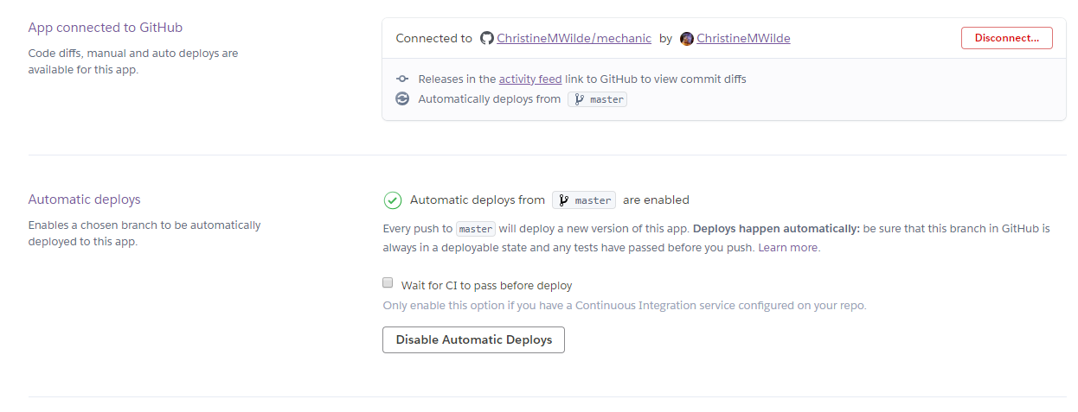

The staging.py environment was set for the Heroku app.

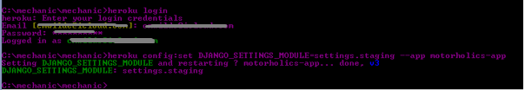

Then the disable static collection was set since the database needs to be setup first before Heroku collects the static files.



Scaling dynos was initiated:

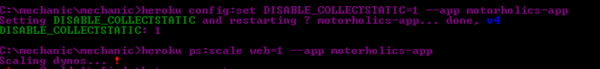

\*Both Procfile and Procfile.local were ‘cleanly’ created in notepad – it was found that if this is not done there are issues that can happen.

**Step 19**

The app was opened in Heroku (also see Heroku logs).



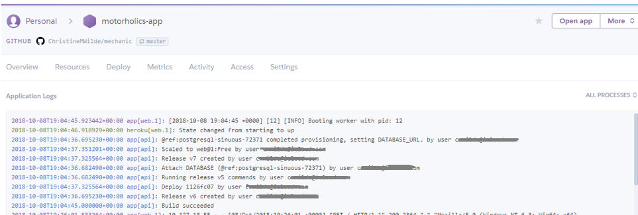

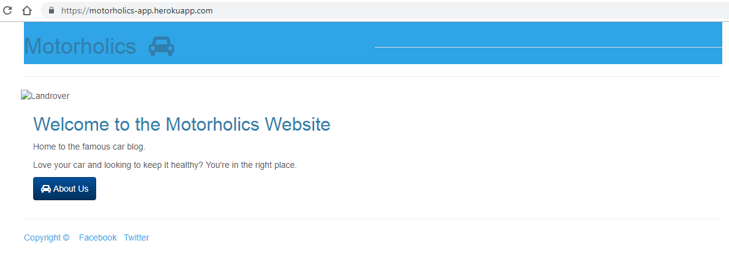

**Step 20**

ClearDB was added under Resources to start setting up the database – the “reconnect=true” was deleted from the end of the variable under the settings.

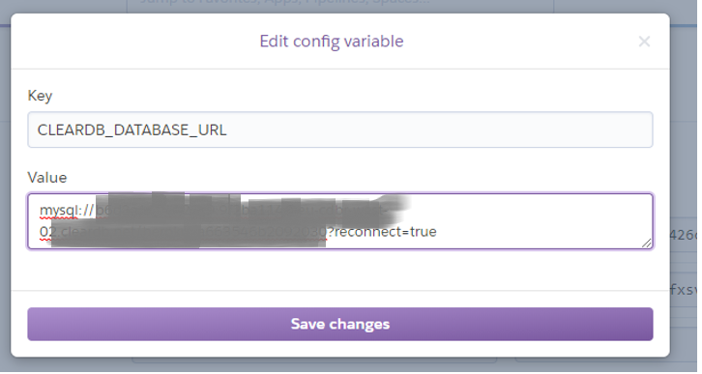

**Step 21**

The dj-database-url was added to requirements\staging.txt file.

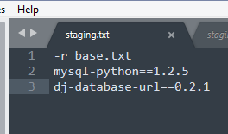

**Step 22**

The staging.py file was updated.

*Before:*

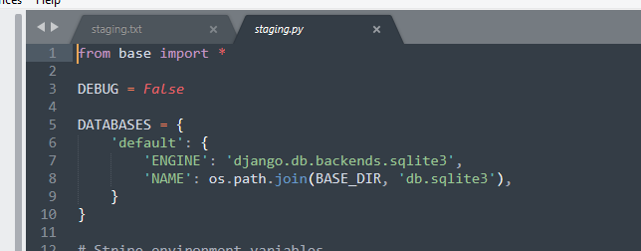

*After:*

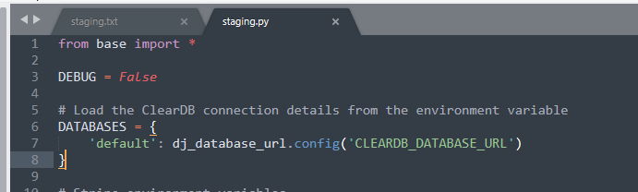

**Step 23**

The changes were pushed to GitHub mechanic repository.

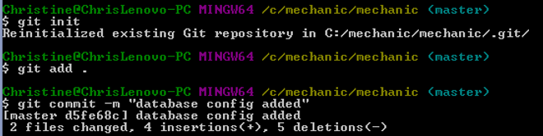

**Step 24**

The database tables were applied using python manage.py.



**Step 25**

Next the database was populated by producing a JSON file dump that landed in the project root location. The file was then pushed to Github.

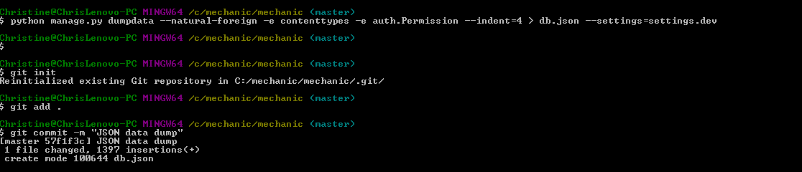

**Step 26**

The file was now pushed to the Heroku app motorholics-app.



**Step 27**

Last few steps were performed to now host the static files that were switched off earlier on via the DISABLE\_COLLECTSTATIC variable.

First the base.txt file was updated with Whitenoise which helps to serve the static files.

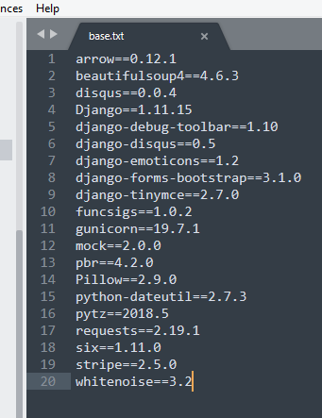

**Step 28**

Whitenoise was installed via the pip and running the base.txt.



**Step 29**

The wsgi.py file under the mechanic folder was update to our new database setting and included Whitenoise.

**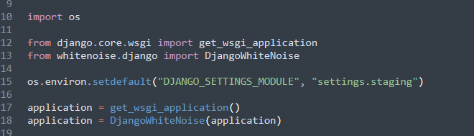**

**Step 30**

After these changes the mechanic GitHub repository was updated.

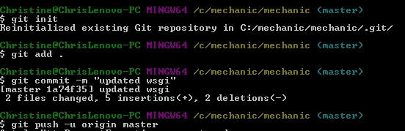

To serve the static files the DISABLE\_COLLECTSTATIC variable was removed from the Heroku dashboard.

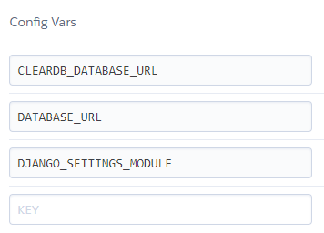

**Step 31**

After initiating a GitHub push Heroku is now hosting Motorholics app.

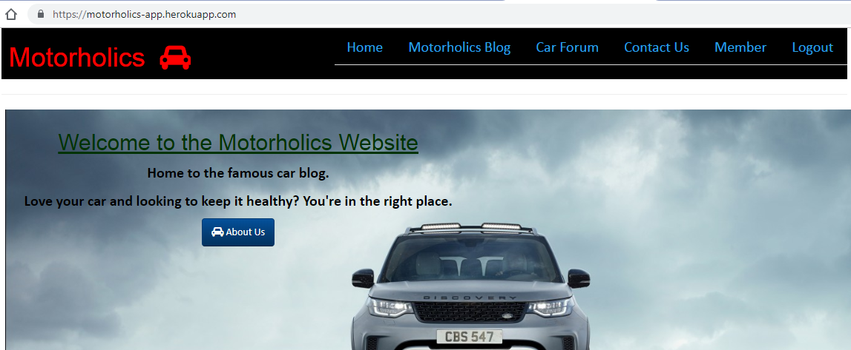

**Step 32**

The very last step was to initiate the git command:

git rm -rf –cached .

git add .

This cleared the current repository and re-added all files so that the .gitignore file could take effect.

## Appendix A: References

<https://www.carparts4less.co.uk>

<https://www.oponeo.co.uk/alloy-wheels>

<https://revive-uk.com/your-repair/paint-repairs/>

<https://www.autoexpress.co.uk/best-cars/98621/flying-cars-2018-will-the-flying-car-market-ever-take-off>

<https://www.autoexpress.co.uk/best-cars/driver-power/91289/best-car-manufacturers-2018>

<https://www.hondaengineroom.co.uk/cars/how-the-honda-s2000-ripped-up-the-rulebook/>

<https://www.topgear.com/car-news/first-look/new-mini-cooper-terribly-proud-be-british>

<https://mycarneedsa.com/blog/whats-happened-to-mot-service-reminders>

<https://www.driving.co.uk/car-clinic/how-to-repair-scratches-and-scuffs-to-car-paintwork/>

<https://www.gov.uk/mot-reminder>

<https://www.theguardian.com/money/2014/oct/01/tax-disc-question-and-answer>